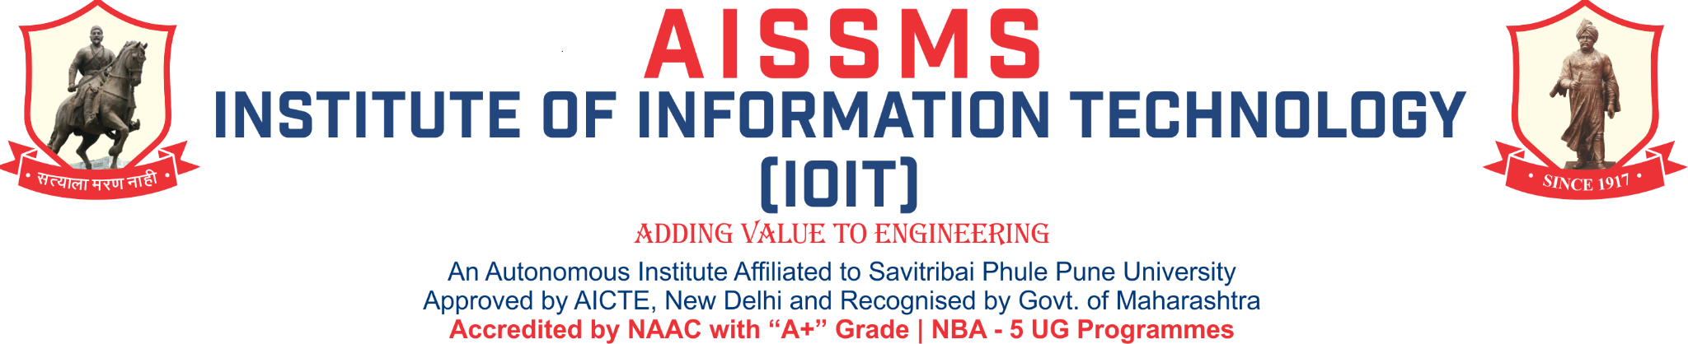
Department of Artificial Intelligence & Data Science
About Oracle Academy

Oracle Academy benefits offer educators and students computer science education resources to advance knowledge, skills development, innovation and diversity in technology fields like Java, database design, and SQL and PL/SQL programming. Oracle Academy membership offers individual learners, educators, and educational institutions access to world-class technology, expertly developed learning materials and curriculum, training and other resources. To be college and career ready, today’s students need computer science classes as part of their educational pathways. Educational Institutes know that delivering high quality education requires rigorous curriculum, engaging resources and skilled, trained, professional teachers. Oracle Academy offers a wide range of classroom courses, self-study instruction, workshops and resources.

Objective of Collaboration:
The objective of this collaborative partnership is
- To train students to examine business case studies and apply their technical knowledge and professional skills to develop online database applications.
- To make students understand how to write basic Java applications and simple applets that include: code reusability, data encapsulation, dynamically downloadable program units, and architecturally neutral and platform-independent programs.
- To make the students proficient business analysts, technical experts in structured query language (SQL), and develop essential professional skills including teamwork, project management.
- To advance computing education of the students as well as the faculties and increase knowledge, innovation, skills development, and diversity.

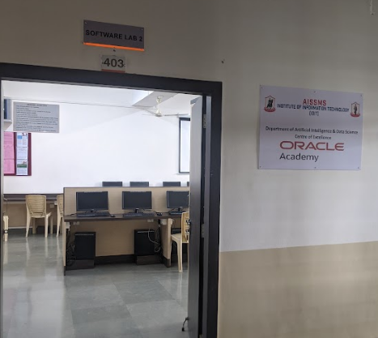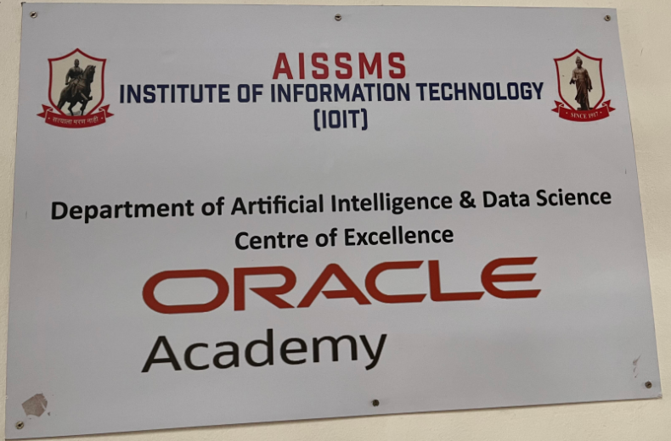

Department of Artificial Intelligence and Data science -Centre of Excellence “Oracle Academy”

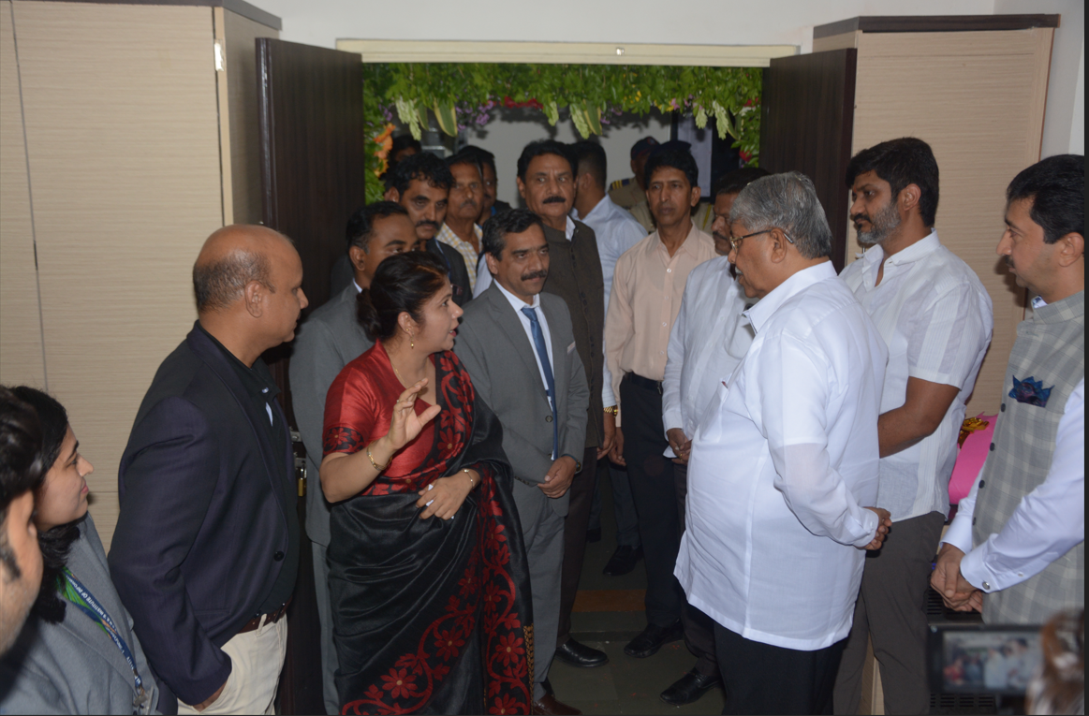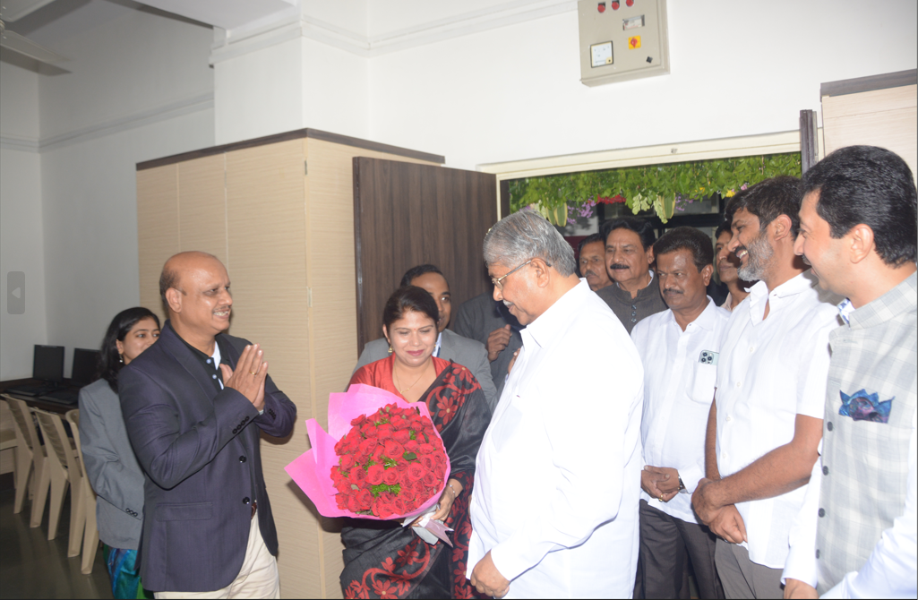
Inauguration Ceremony of Department of Artificial Intelligence and Data Science Centre of Excellence “Oracle Academy” by Hon. Chief Guest Shri. Chandrakant Patil (Minister of Higher and Technical Education Government of Maharashtra) presided by Shri.Siddharth Shirole (MLA Shivajinagar onstituency ,Pune,Maharashtra) dated on 23.07.2023

