Photo Gallery E&TC
E&TC Photo Gallery
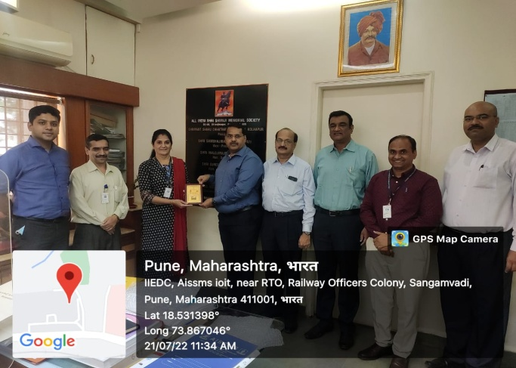 |  | 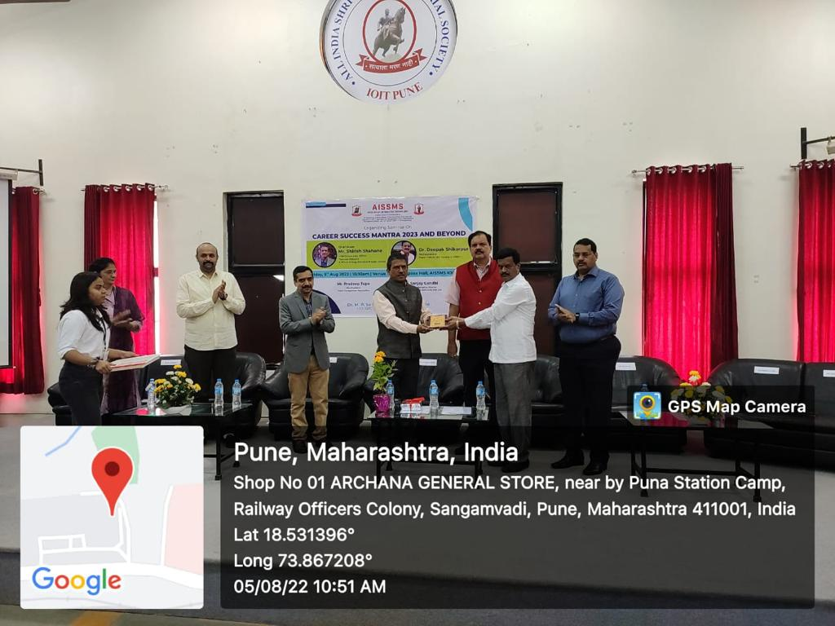
E&TC department signed MoU with Pune Management Association, Pune on 21/07/2022 |  | Seminar- “Career Success Mantra 203 And Beyond” Date-05/08/2022 Guest-Dr.Deepak Shikarpur, Mr. Shirish Shahane and Mr.Sanjay Gandhi
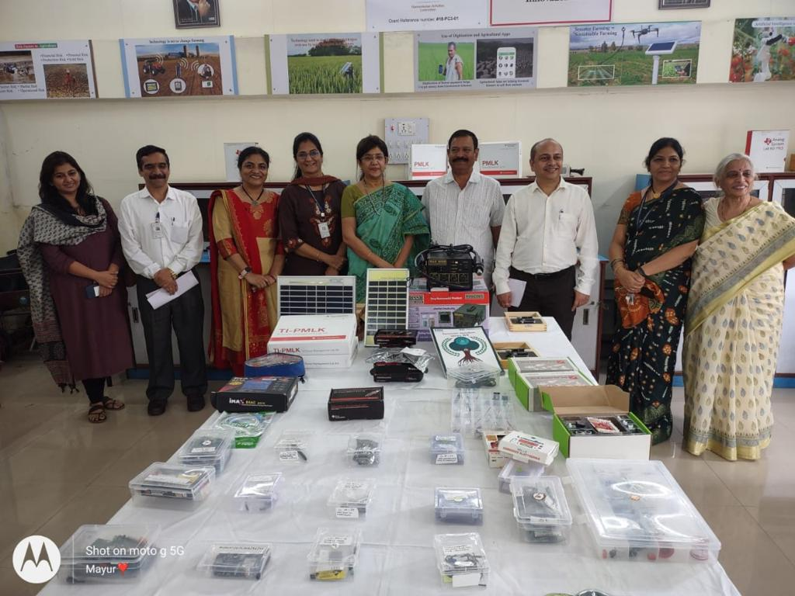 |  | 
Ms. Vandanatai Chavan, Member of Parliament, visited Affordable agriculture lab and Texas Instrumentation Lab. The event was blessed with the presence of Honorary Joint Secretary Mr. Suresh Pratap Shinde ,Principal Dr.P.B.Mane, Jagdish Choudhary, Ms.Divyatai Chavan and Ms. Sanjeevanitai Joglekar.Hod Dr.M.P.Sardey Hod Dr.Ashpana Shriralkar & Mrs.V.K.Patil |  | Lab assistant Miss.Paratiksha Chavhan won Lokmat Digital Influencer Award-2022 on 21/08/2022
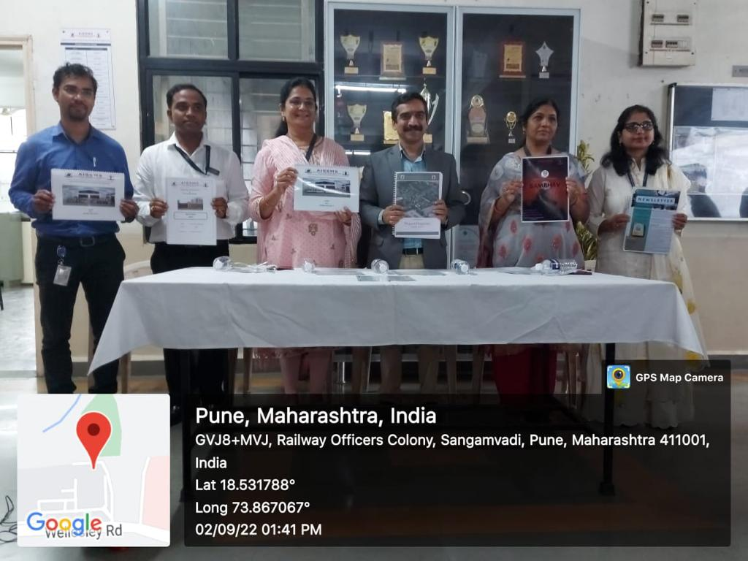 |  | 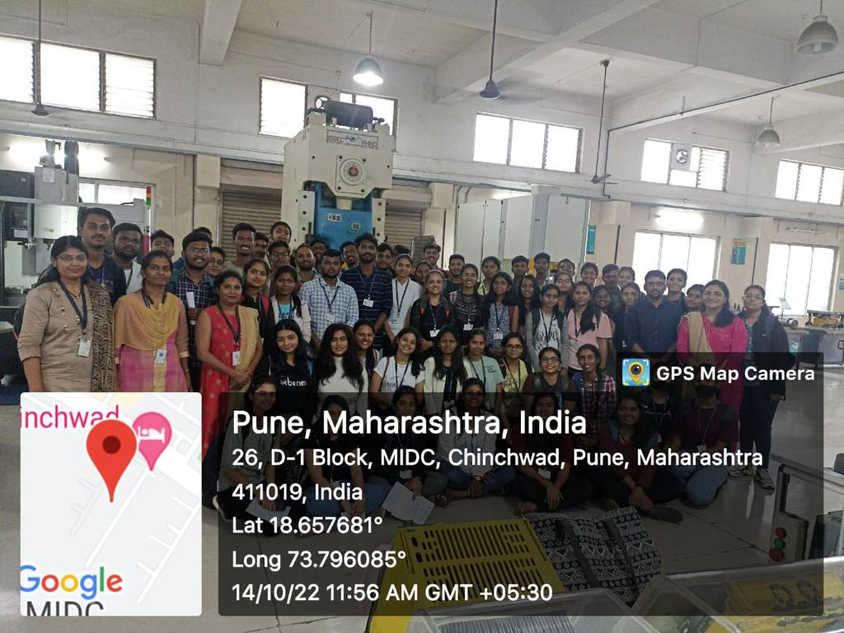
Inauguration of department magazine Telescan and Newsletter at VERITAS Event Date-02/09/2023. |  | Industrial visit at IMTMA, Pune Class- BE E&TC Date-14/10/2023 Faculty coordinators-Mrs.V.K.Patil, Mrs.Deepali Yewale, Mrs.H.B.Magar &Mrs.S.A.Panwar.
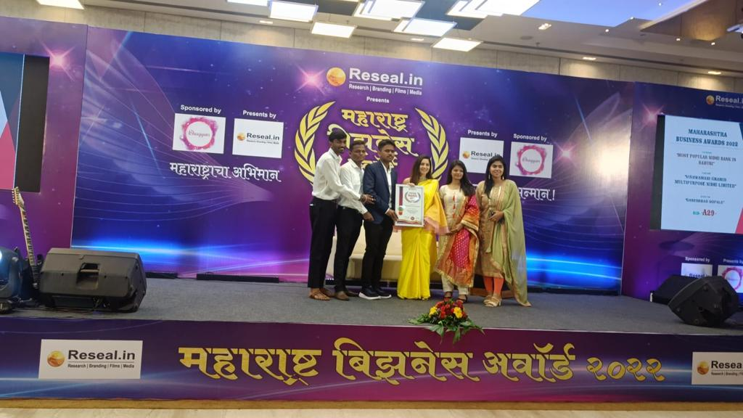 | 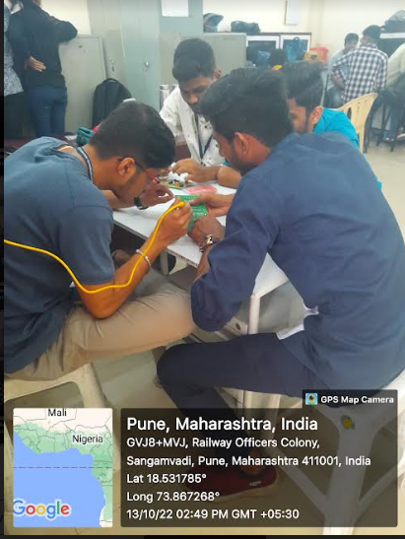
Mr.Prathmesh Yechwad, T.E E&TC Student was awarded with the Young Marathi Entrepreneur award along with the Most Prominent and Trusted Software company in Maharashtra award for his company, by Maharashtra Business Award 2022. Date-06/11/2022 | Workshop-Skill Development using Microcontroller  Class-TE  Date-13/10/22-17/10/22
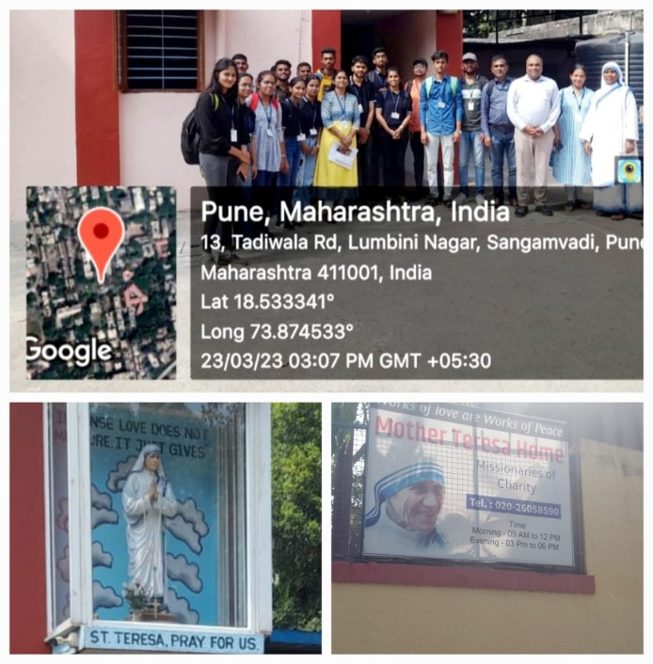 | 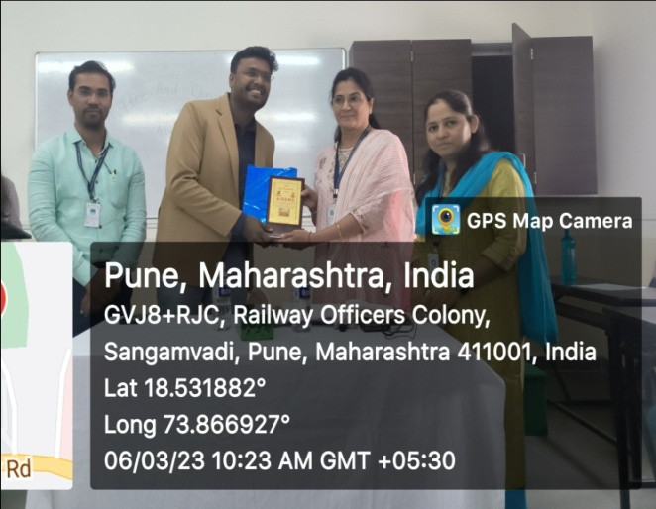
Social Visit to Missionaries of Charity, Pune. Date-23/03/2023 Faculty coordinators- Mrs. Vineeta Philip & Mr. M. P. Gajare were & Mrs. A. A. Randive & Mr. C. K. Bhange. Class-SE | “Coffee and conversation with the Alumni” Alumni-Mr.Shubham Agarwal, Business Consultant at Ernst & Young, Date- 06/03/2023.  The event was coordinated by Mrs. Archana Ubale, Alumni Coordinator of department ,Mr.Devendra Itole ,IIEDC coordinator
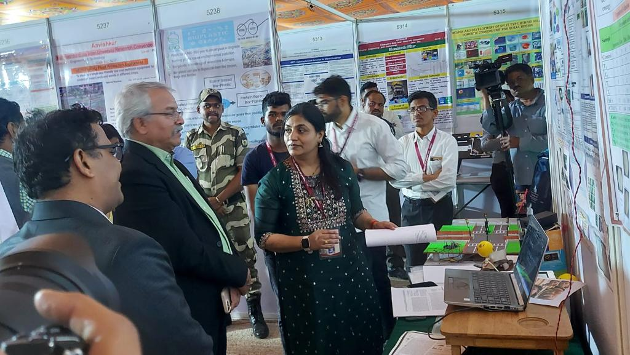 | 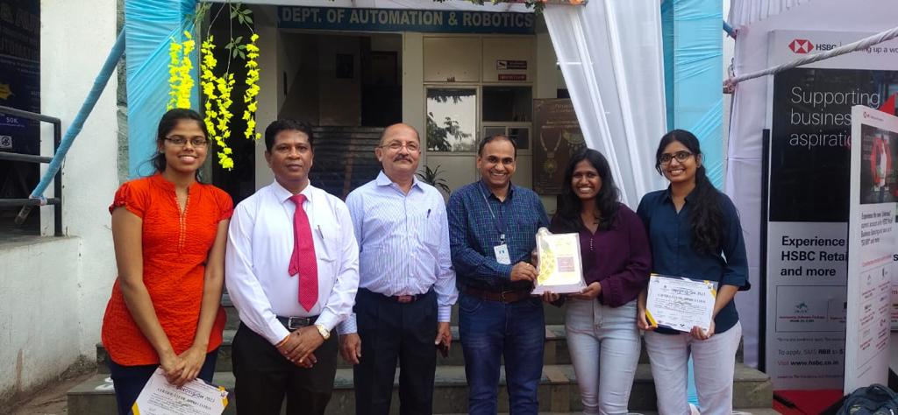
Mrs.Varsha Patil Assistant Professor, Electronics and Telecommunication Engg. a member of SPPU Pune, Avishkar Team which Conferred 2nd Position in the 15th Maharashtra State-Level Inter-University Research Convention for Post PG Student Level at Avishkar 2023. | Project Group of Shubhangi Kawale Tejashreee Sakhare & Achal Singh secured 3RD rank in TECHGLINT BY INNOVISION-23 organized in JSPM RSCOE,PUNE  Project title: Portable health monitoring system using AI and ML  Project guide: Dr. Sarika Panwar.

