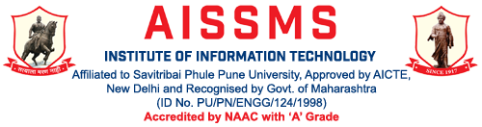
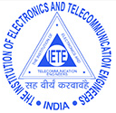
IETE Activities Report 2019-20
E & TC Dept
Sr. No | Description of Event | Date | Resource Person  (Organization) | Participation Details | Coordinated By | Level of Activity | Relevance to
 |  |  |  |  |  |  | POs | PSOs
IETE
1 | 66th IETE Foundation Day celebration expert talk on “Artificial Intelligence in health care and automotive industry” | 08/11/ 2019 | Mr. Pratap Sanap Solution Architect Persistent system, Pune | Staff & students =150 | E & TC Department | Institute | 1,2,3,4,5,11,12 | 1,2
2 | ‘Design Thinking’ AIC-ADT Baramati | 20/12/2019-21/12/2019 | Dr. Manoj Nagmode | BE | Mrs. D. M. Yewale | Institute | 1,2,3,4, 5,11,12 | 1,2

On occasion of
“66thIETE Foundation Day”
Expert talk on
“Artificial Intelligence in health care and automotive industry”
On 8th November 2019
Supported by
Institution of Electronics and Telecommunication Engineers (IETE)
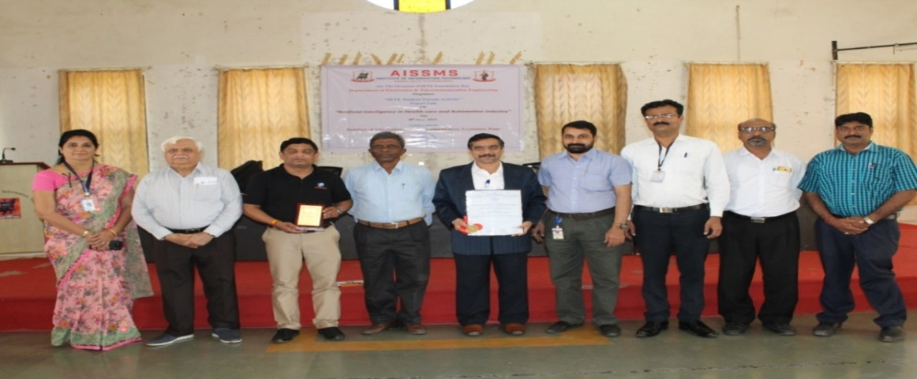
From left Dr. Mohini Sardey H. O. D. E&TC AISSMS IOIT, Shri. G. K. Dawara, Past Chairman IETE Pune Centre,Guest of honor and speaker Mr. Pratap Sanap Solution Architect Persistent system, Pune, Mr. Kishor Shende, Chairman IETE Pune Centre, Dr. P. B. Mane PrincipalAISSMS IOIT,Dr. Prashant Patel and IETE council members

The All India Shri Shivaji Memorial Society’s department of Electronics and Telecommunication Engineering had organized Expert talk under Institution of Electronics and Telecommunication Engineers (IETE) student’s forum (ISF) on 8thNovember 2019.
Expert talk was on “Artificial Intelligence in health care and automotive industry” by Mr. Pratap Sanap Solution Architect Persistent system, Pune. He shared his experiences of development of modeling software projects. Also he motivated the students to seek the jobs in the field of automation and to be ready from second year of engineering to do projects in this field. He discussed about important trends in upcoming decade and focused on artificial intelligence and machine learning applications.
On the occasion of 66thIETE Foundation Day, Mr. Kishor Shende Chairman IETE Pune had welcome all and shared about Foundation Day and IETE activities under Pune section. Also he felicitated Mr. Pratap Sanap with flowers bouquet and IETE memento.Dr. P. B. Mane, Principal AISSMS IOIT was awarded with Dr. B. R. Batra IETE award 2019 from head office. Dr. P. B. Mane delivered the lecture on achievements submitted for Dr. B. R. Batra award. Dr. Prashant Patel IETE council memberread president message of foundation day. Shri. G. K. Dawara,past chairman IETEgave vote of thanks.

Prof. Geeta D. Salunke Dr. M. P. Sardey
PB Dept. Coordinator PB Coordinator & HoD

