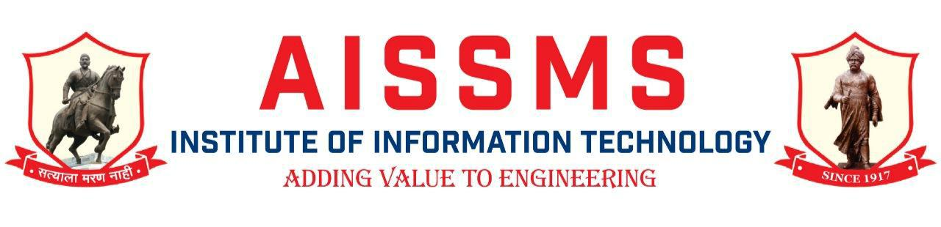

Department of Instrumentation Engineering

2020-21 Sem-I
Activity Report
Sr. No | Date | Activity details | Speaker/Judge | Organizer/ Staff coordinator/ Student coordinator | Number of students, Staff
1 | 08/06/2020 | Webinar on “Career challenges after COVID 19 Pandemic situation” | Mr. Abhijeet Murgunde  MNC Company ,Pune | Mrs.S.V. Kulkarni and Mr. H.P.Chaudhari | Students =66
2 | 18/09/2020 | Webinar on “Future role of Instrumentation in Industry”. | Mr. SadanandKulkarni, Director, Seiton technologies, Pune. | Mr.S.S.Jagtap and Dr. B.N.Mohapatra | Students=60

