Department of Electronics & Telecommunication Engineering
Technical Activities
Conducted Under
ISTE


Report of ISTE Program conducted in year 2020-21
The All India Shri Shivaji Memorial Society’s department of Electronics & Telecommunication Engineering Sciences had organized following events under ISTE in year 2020-21

Sr No | Date | Event | Name of Resource Person | Name of Company/college | Phone No | Mail Id | Name of Internal Staff | Participants Class &Div
1 | 9/6/2020 to 15/6/2020 | One week FDP on “Research Methodology: Data Collection Methods, Research Tools & Techniques” | Dr. Y. P. Patil,  Dr. S. L. Kurkute,  Dr. S. N. Zaware,  Dr. S. B. Dhonde,  Dr. S. A. Panwar, Dr. M. A. Thalor, Dr. M. P. Sardey, Dr. S. M. Bakre,  Dr. K. G. Wadikar,  Dr. D. K. Shedge, Dr. K. S. Wagh,  Dr. V. K. Bairagi, Dr. P. B. Mane  Dr. Nidhi Sharma,  Dr. D. R. Shende,  Dr. S. V. Limkar, Dr. J. B. Patil,  Dr. P. G. Musrif,  Dr. V. K. Harpale | AISSMS IOIT, (PCCOE |  |  | Dr. V. K. Bairagi | Faculties and students
2 | 16-06-20 | Webinar on Machine learning opportunities and research challenges” | Mr. Manesh Kokare | SGGS Nanded | 9421474393 | manesh.kokare@gmail.com | Deepali Yewale , Vineeta Philip | Faculties and students
3 | 27/06/2020 ,9.00 pm to 10.30 pm | Webinar | Mr.Parag Ashok Deshpande | Cyient Ltd, Pune | 96504 88110 | deshpandeparag19@gmail.com | Sweta M Patil | Faculties and students
4 | 27-06-20 | Webinar | Mr. Alex Benjamin | Jetking, Hadapsar | 8983461181 | Alex. benjamin@jetking.com | Suprriya Lohar, Shobhika Gopnarayan, C. K. Bhange | Faculties and students
5 | 29/8/2020 | Webinar | Mr.Shivaji Nawatake | SIR Automation Industries |  |  | Deepali Yewale | Faculties and students

1) One week FDP on “Research Methodology: Data Collection Methods, Research Tools & Techniques

Day | Speaker | Topic
Day 1 | Dr. Y. P. Patil | Foundation of Research, Types of Research, Problem definition & setting the objective, Criteria/Characteristics of a good research problem
Day 1 | Dr. S. L. Kurkute | Research Design & methods, testing of hypothesis
Day 1 | Dr. S. N. Zaware | Systematic review of literature { Effective use of IEEE , Elsevier website}
Day 2 | Dr. Y. P. Patil | Basic instrumentation, characteristics of instruments, design of experimental setup
Day 2 | Dr. S. B. Dhonde | Data collection, sample design and techniques, ethics
Day 2 | Dr. S. A. Panwar | Data preparation & showcase (use of figures, table, types, box plot)
Day 3 | Dr. M. A. Thalor | Probability and probability distribution: A special focus on normal distribution, Chi square test, Z test with examples
Day 3 | Dr. M. P. Sardey | Parametric and non-parametric tests
Day 3 | Dr. S. M. Bakre | Correlation and regression analysis, Types of regression
Day 4 | Dr. K. G. Wadikar | Principal component analysis, Multivariate & ANOVA, Discriminant function analysis, Exploratory factor analysis & Confirmatory factor analysis
Day 4 | Dr. D. K. Shedge | Different simulation software (comparison of few popular software) Open source software’s
Day 4 | Dr. K. S. Wagh | Introduction to IPR and types
Day 5 | Dr. V. K. Bairagi | Technical paper writing, Plagiarism, ethics, Journal matrices
Day 5 | Dr. P. B. Mane | How to write good thesis- Tips and Case study
Day 5 | Dr. Nidhi Sharma | Paper submission to Elsevier / IEEE Transaction , Orcid Id
Day 6 | Dr. D. R. Shende | Writing a research proposal { Individual research proposal, Institutional proposal}
Day 6 | Dr. S. V. Limkar | Reference writing software tools and demo (like Mandalay and its comparison with other similar software)
Day 6 | Dr. J. B. Patil | Latex writing Part 1
Day 7 | Dr. P. G. Musrif | Latex writing Part 2
Day 7 | Dr. V. K. Harpale | Case study / Successful story of recently Completed PhD

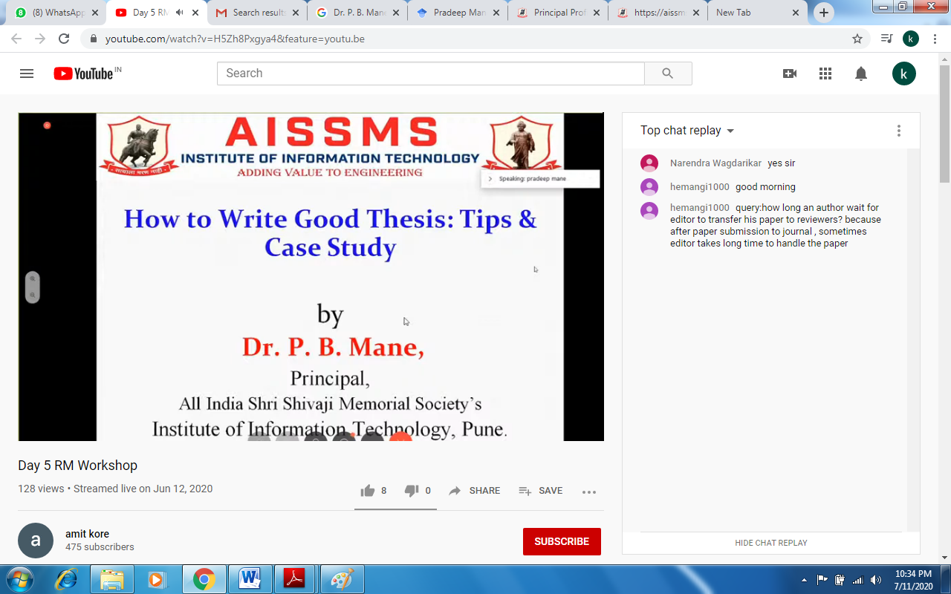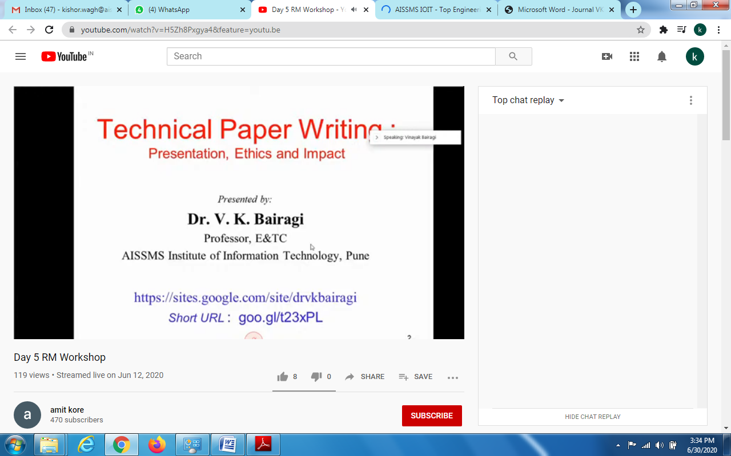

- Webinar was on “Machine learning opportunities and research challenges” by Dr. MANESH B KOKARE, HOD, SGGS Nanded on 16-06-20 .Speaker started with AI evolution. The speaker gave examples of machine learning in retail, marketing, healthcare, telco and finance. AI also helps the physically challenged people like the blind to identify currency notes, shopping etc. AI techniques can also be used by common man, where he quoted the example of ANYBODY CAN DANCE. Where in computer vision technique can be used for performing motion transfer from one subject to another.

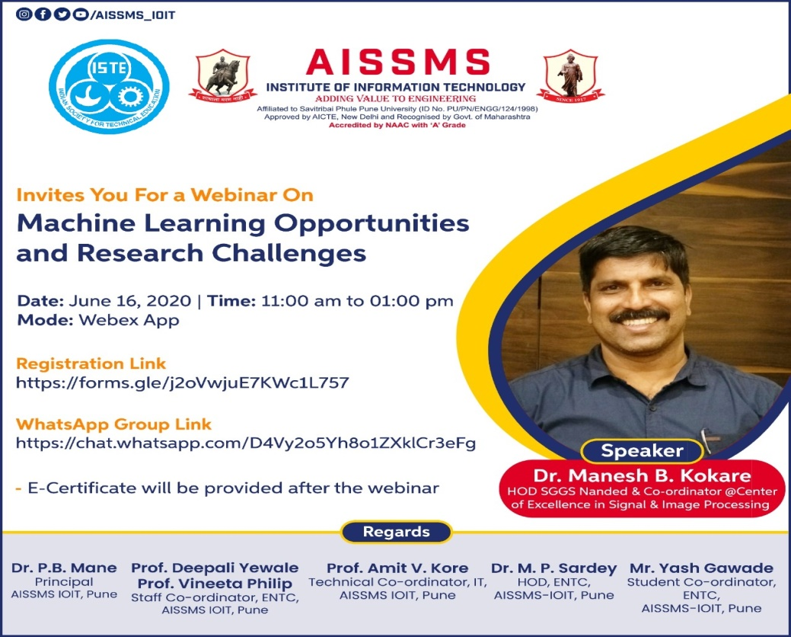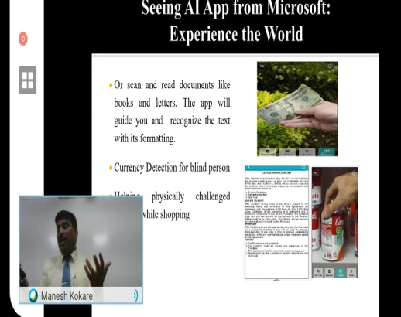

- Webinar was on “Introduction to Analog Mixed Signals verification” by Mr.Parag Ashok Deshpande ,Team Lead AMS Verification ,Senior Design Engineer Cyient Ltd,Pune on 27/ 06/2020 . The webinar started with Introduction to VLSI, type of chip, Chip design flow ,transistor level etc. Application specific ASIC.Use of automatic transiction code like Verilog, VHDL, UVM were also discussed.
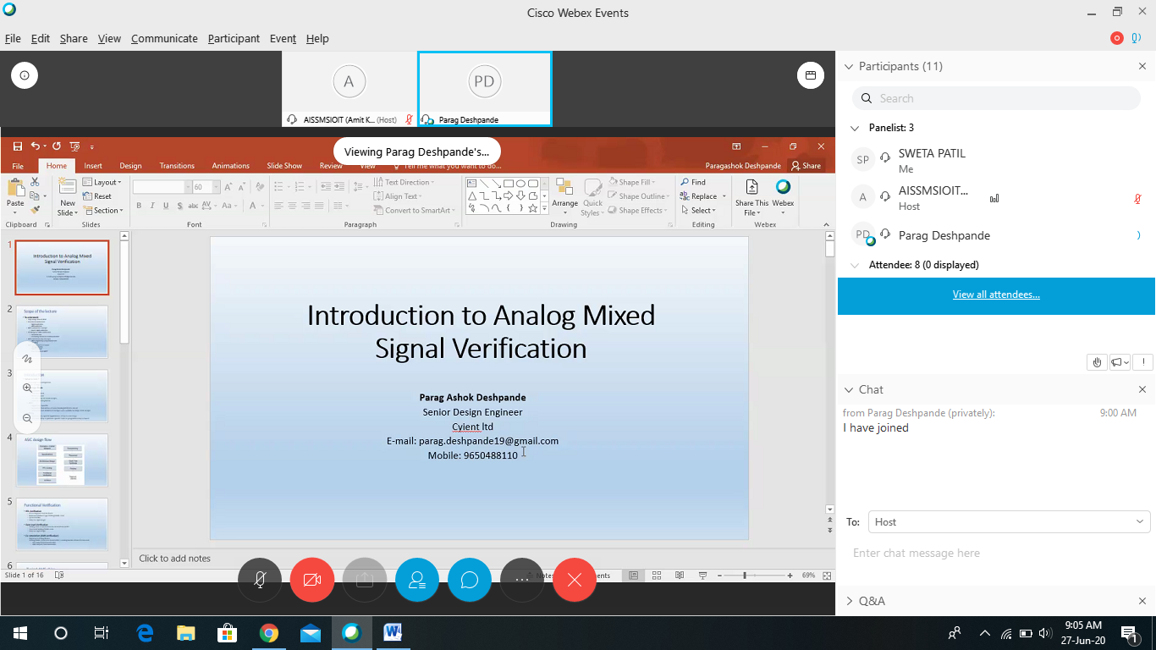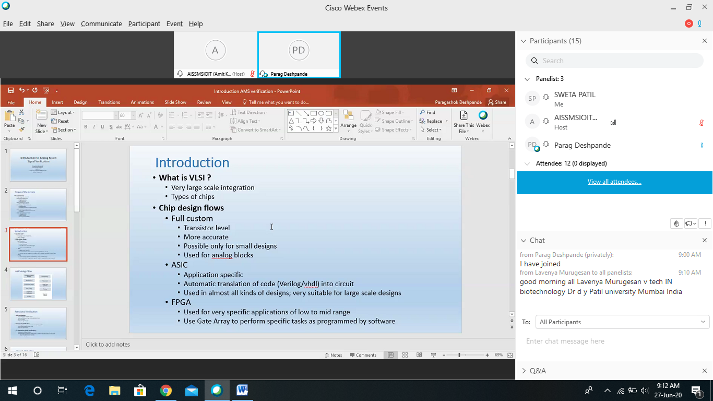

- Webinar on “Carrier Growth Opportunities with Network And Security Certification” by Mr. Benjamin Alex on 27/6/2020 was conducted .The webinar is started with basics of Networking like OSI Model,routers. Speaker also covered different Networking & Security cerification like CCNA, CCNP, CCIE, Cisco Enterprise Cisco Security, Data Center Courses.He also explain the syllabus syllabus.how to prepare for exam,what will salary after passing the exam.

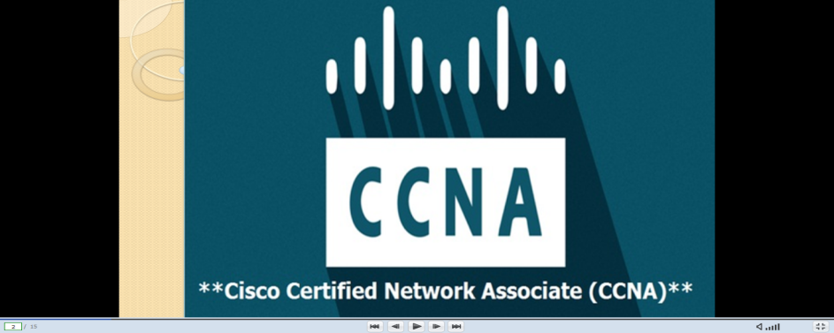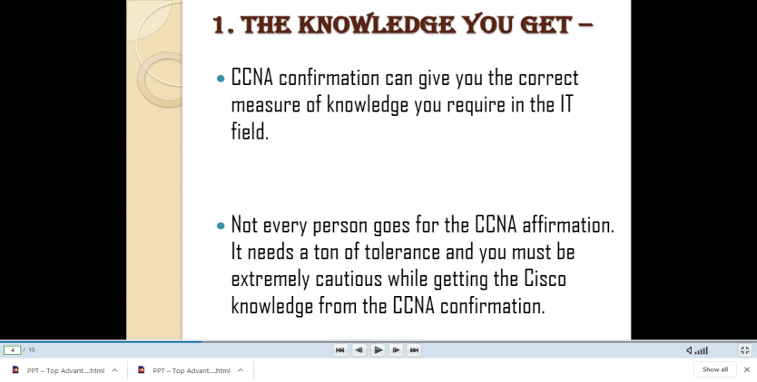

- Webinar on “Emerging Industrial IoT Applications” by Mr.Shivaji S. Nawatake was conducted on 29.08.20. The webinar is started with information of IoT and their application areas. He also explained system requirement of Industrial IoT, Ultra low power design considerations, Industrial IoT communication protocol,Then speaker explored applications of IoT in Mining, Healthcare, Automation and Agriculture. Speaker had given demo of applications designed by him in different fields.

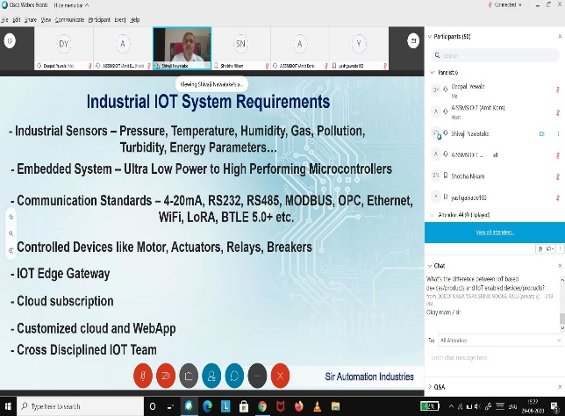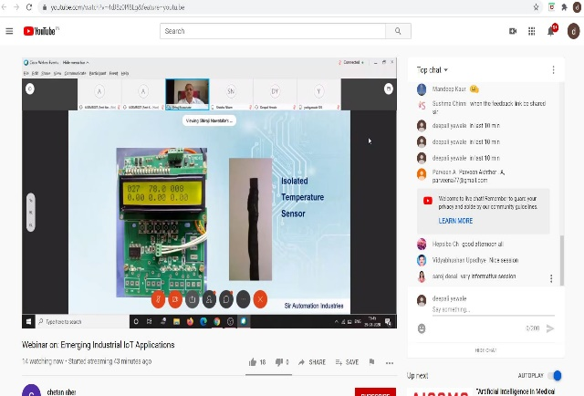

Prof. S.M.Patil Dr. M.P.Sardey
E&Tc ISTE Coordinator HOD

