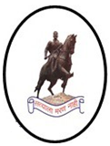 | Technical lecture  Under  ISF Activity  On 27th August 2018. | 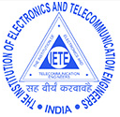
Supported by
Institution of Electronics and Telecommunication Engineers (IETE)
Organized by
Department of Electronics and Telecommunication Engineering
All India Shri Shivaji Memorial Society’s,
Institute Of Information Technology, Pune
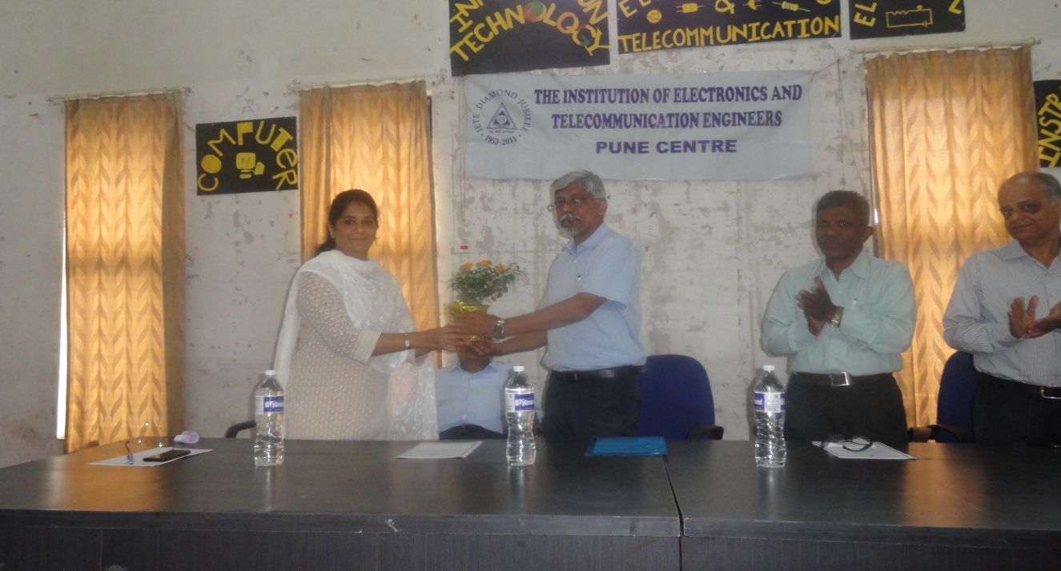
From left Dr. Mohini Sardey H. O. D. E&TC AISSMS IOIT, Mr. Nandan Kharade Director, ABACUS Tektronix Pvt. Ltd, RNA Automations Pvt. Ltd., Mr. Kishor Shende, Chairman IETE Pune Centre, Dr. R. D. Kharadkar, Hon. Secretary IETE Pune Centre

The All India Shri Shivaji Memorial Society’s department of Electronics and Telecommunication Engineering had organized “technical talk” under Institution of Electronics and Telecommunication Engineers (IETE) student’s forum (ISF) on 27th August 2018.
Expert talk was on “Embedded System and its Applications” by Mr. Nandan Kharade, Director, ABACUS Tektronix Pvt. Ltd, RNA Automations Pvt. Ltd. He shared his experiences of designing embedded systems and how to plan for designing any circuit. Also he motivated the students to seek the jobs in the field of embedded system.
On the occasion of ISF activity, Mr. Kishor Shende, Chairman IETE Pune Centre and Dr. R. D. Kharadkar, Hon. Secretary IETE Pune Centre was present. Mr. Kishor Shende shared about IETE activities under Pune section. Dr. R. D. Kharadkar addressed the students about different fields in Electronics and Telecommunication Engineering and opportunities in future.

ISF Activity
On occasion of
“65th IETE Foundation Day”
Expert talk on
Robotics & its applications
On 2nd November 2018

Supported by
Institution of Electronics and Telecommunication Engineers (IETE)
Organized by
Department of Electronics and Telecommunication Engineering
All India Shri Shivaji Memorial Society’s,
Institute Of Information Technology, Pune
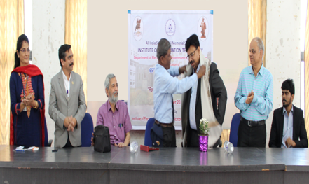

From left Dr. Mohini Sardey H. O. D. E&TC AISSMS IOIT, Dr. P. B. Mane Principal, AISSMS IOIT, Guest of honor Mr. A. D. Jog, Retired Police Director, Mr. Kishor Shende, Chairman IETE Pune Centre, speaker Mr. Prasad Kulkarni, vice president, Logicon Technosolutions , Dr. R. D. Kharadkar, Hon. Secretary IETE Pune Centre, Mr. Rohit Pansare cospeaker.

The All India Shri Shivaji Memorial Society’s department of Electronics and Telecommunication Engineering had organized Expert talk under Institution of Electronics and Telecommunication Engineers (IETE) student’s forum (ISF) on 2nd November 2018.
Expert talk was on “Robotics & its applications” by Mr. Prasad Kulkarni, vice president, Logicon Technosolutions and Mr. Rohit Pansare. Mr. Prasad Kulkarni shared his experiences of cobots manufacturing and how to program cooperative robots for any application. Also he motivated the students to seek the jobs in the field of automation.
On the occasion of 65th IETE Foundation Day, Mr. Kishor Shende, Chairman IETE Pune Centre and Dr. R. D. Kharadkar, Hon. Secretary IETE Pune Centre was present. Mr. Kishor Shende shared about Foundation Day and IETE activities under Pune section. Dr. R. D. Kharadkar addressed the audience about different fields in Electronics and Telecommunication Engineering and opportunities in future.
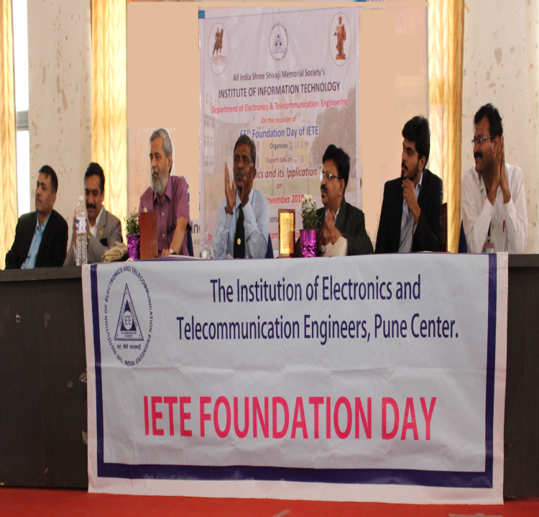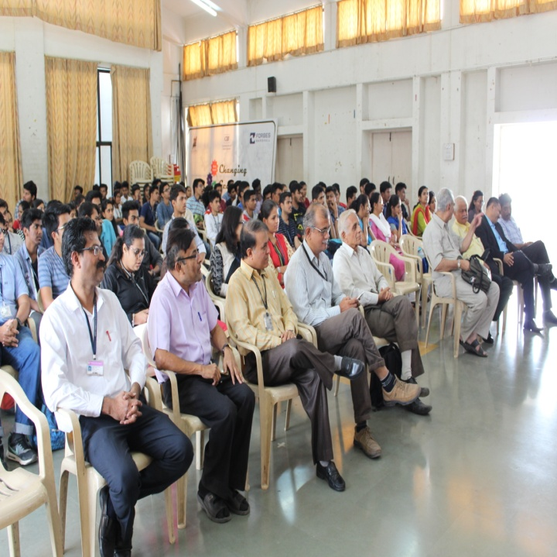

Expert talk and demonstration on Robotics & its applications

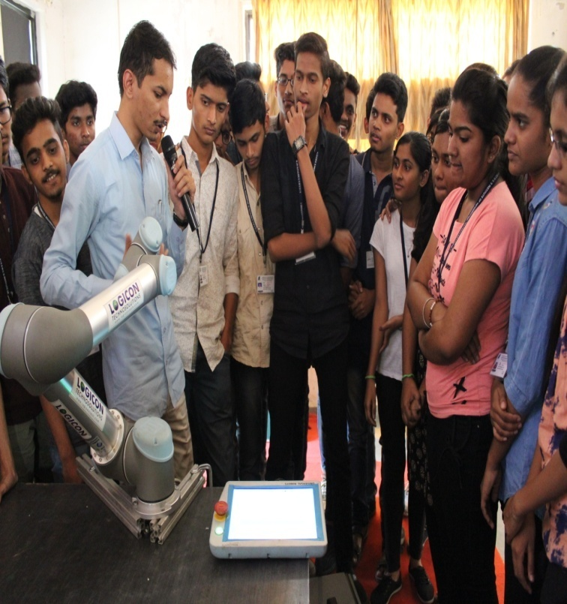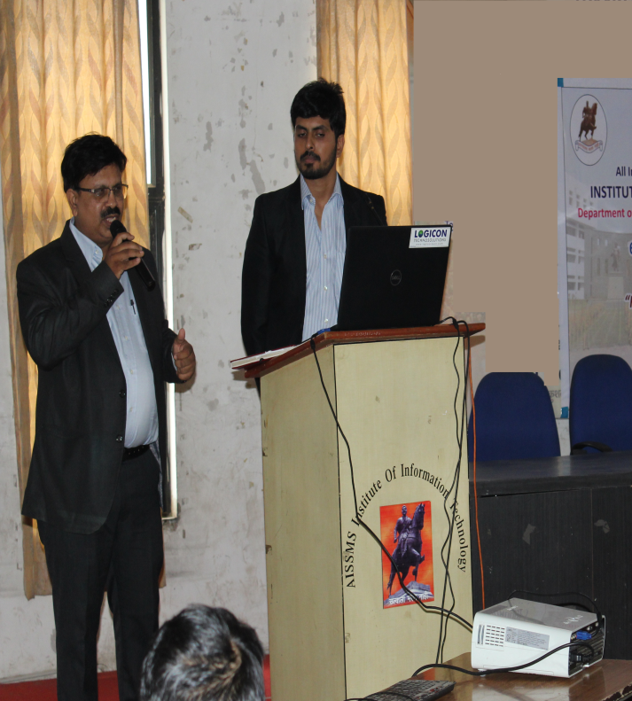

ISF Activity
on
Celebration of
IETE Student’s Day
on
1st February, 2019

Supported by
Institution of Electronics and Telecommunication Engineers (IETE)
Organized by
Department of Electronics and Telecommunication Engineering
All India Shri Shivaji Memorial Society’s,
Institute Of Information Technology, Pune
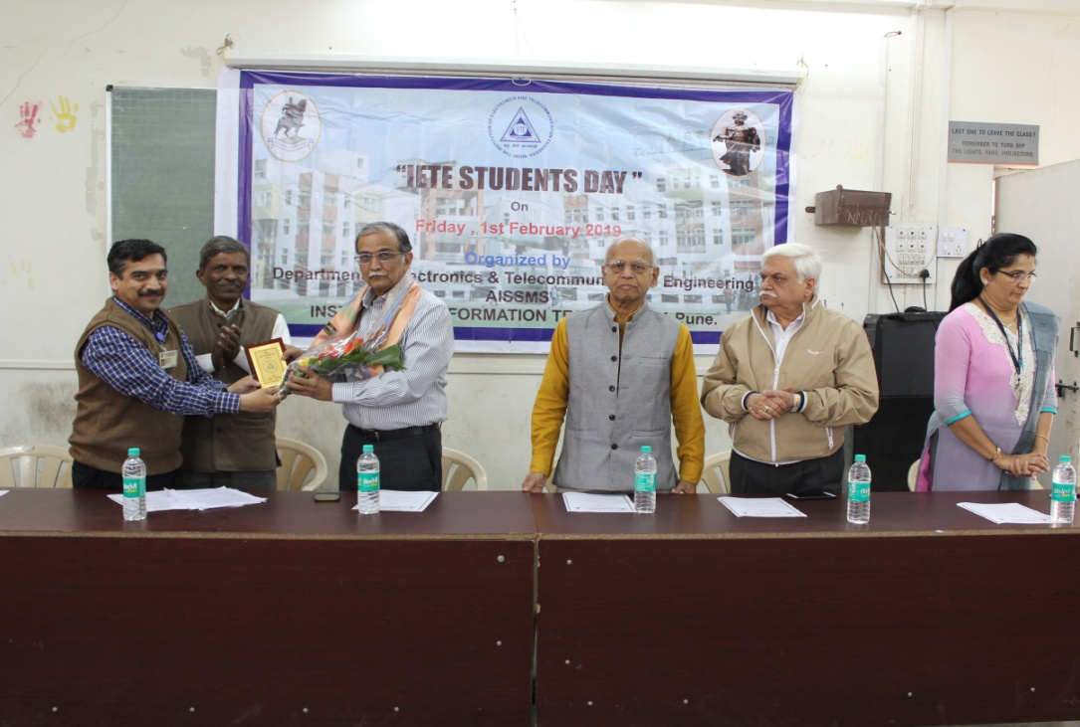
From left Dr. P. B. Mane Principal, AISSMS IOIT, Mr. Kishor Shende, Chairman IETE Pune Centre, Chief Guest and speaker Mr. Shrikant Kulkarni BE (E&TC), COEP, Pune & Industrialist, Prof S K Khedkar Mentor, Western Zone, Shri G. K. Dawara Past Chairman IETE Pune and Dr. Mohini Sardey H. O. D. E&TC AISSMS IOIT

The All India Shri Shivaji Memorial Society’s department of Electronics and Telecommunication Engineering had organized Expert talk on the occasion of IETE student’s day celebration under Institution of Electronics and Telecommunication Engineers (IETE) student’s forum (ISF) on 1st February 2019.
Expert talk was on “ERP Software Solutions for Manufacturing Industries” by Mr. Shrikant Kulkarni BE (E&TC), COEP, Pune & Industrialist. Mr. Shrikant Kulkarni shared his experiences of automation and use of ERP software for reports management. Also he motivated the students to develop attitude towards learning approach.
On the occasion of IETE student’s day, Mr. Kishor Shende, Chairman IETE Pune Centre and Prof S K Khedkar, Mentor, Western Zone was present. Mr. Kishor Shende shared about IETE activities under Pune section. Prof S K Khedkar addressed the audience about aspects of the IETE vision mission.

IETE Student’s Day

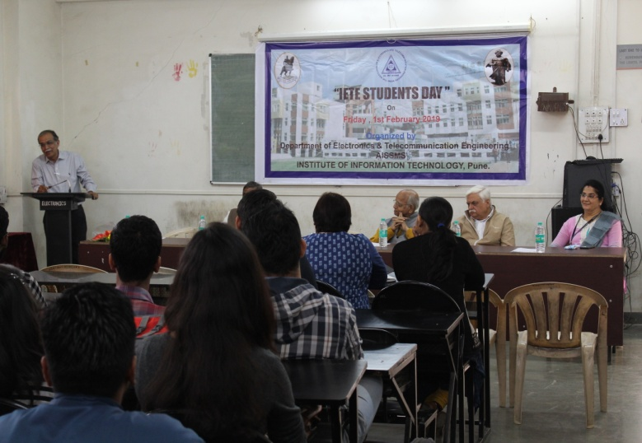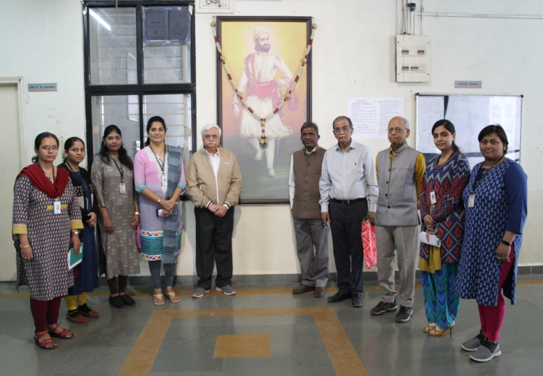

Expert talk on ERP Software Solutions for Manufacturing Industries

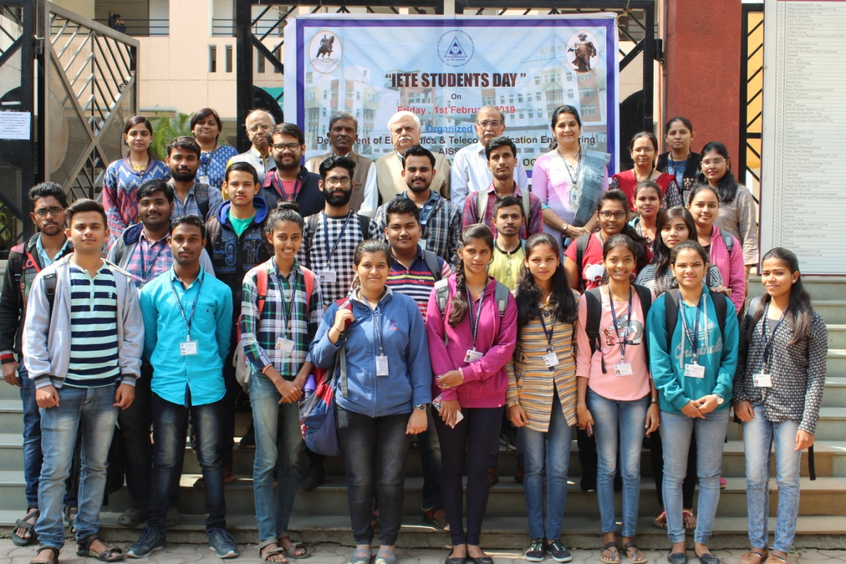
ISF Activity
on
Celebration of
International Women’s Day
on
8th March, 2019

Supported by
Institution of Electronics and Telecommunication Engineers (IETE)
Organized by
Department of Electronics and Telecommunication Engineering
All India Shri Shivaji Memorial Society’s,
Institute Of Information Technology, Pune
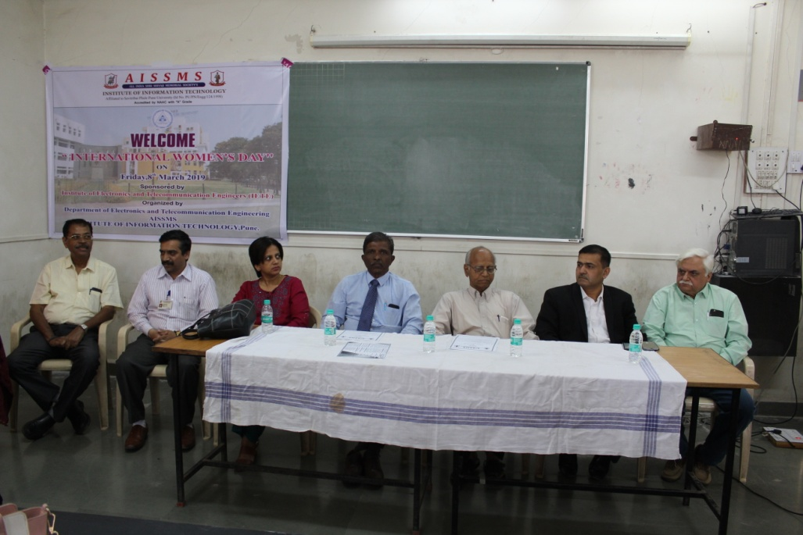
From left C.V. Mahadevan, Dr. P. B. Mane Principal, AISSMS IOIT, Chief Guest and speaker Dr.Leena Tathe MBBS, Mr. Kishor Shende, Chairman IETE Pune Centre, Prof S K Khedkar Mentor, Western Zone, Mr. Atul Joshi treasurer IETE Pune section, Shri G. K. Dawara Past Chairman IETE Pune.

The All India Shri Shivaji Memorial Society’s department of Electronics and Telecommunication Engineering had organized Expert talk on the occasion of International women’s day celebration under Institution of Electronics and Telecommunication Engineers (IETE) on 8th March 2019.
Expert talk was on “Woman health awareness about PCOS” by Dr. Leena Tathe MBBS and DGO science, Karad. She created awareness about the symptoms and precautions of PCOS and hygiene routine for women. Also the second speaker Mrs. Prerana Bhuskute addressed about the benefits of Yoga to gain a healthy body.
On the occasion of International women’s day, the prize distribution ceremony was held for nationwide competition for college students on laws related to woman act, sponsored by Mahila Ayog and conducted by International Complaint Committee (ICC) and women sports competition like Tug of war, carom, table tennis and rangoli organized by AISSMS IOIT. AISSMS IOIT initiated cloth donation for needy women under national service scheme. Mr. Kishor Shende, Chairman IETE Pune Centre and Prof S K Khedkar, Mentor, Western Zone was present. Mr. Kishor Shende shared about IETE activities under Pune section. Prof S K Khedkar motivated the ladies to participate in technical activities.

Lecture on Woman health awareness about PCOS
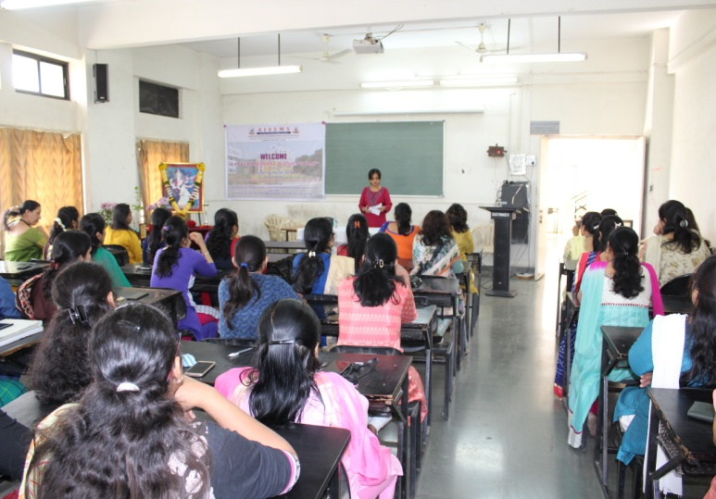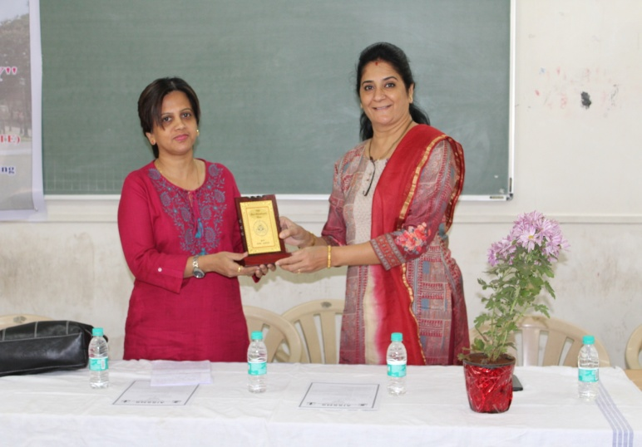

Prize distribution

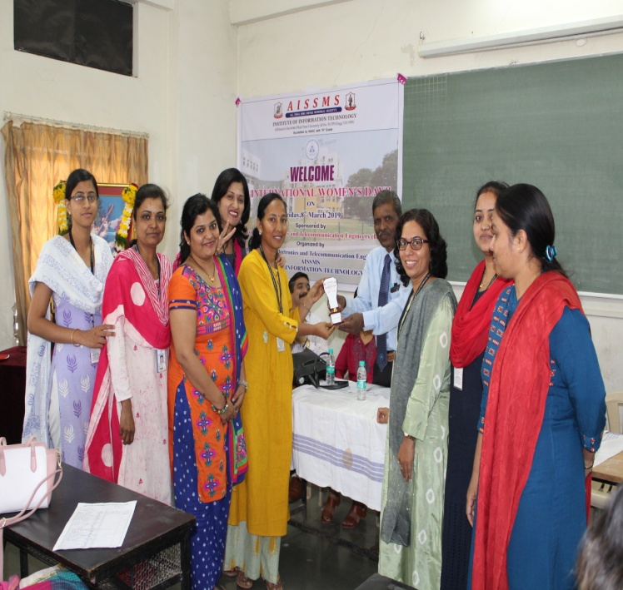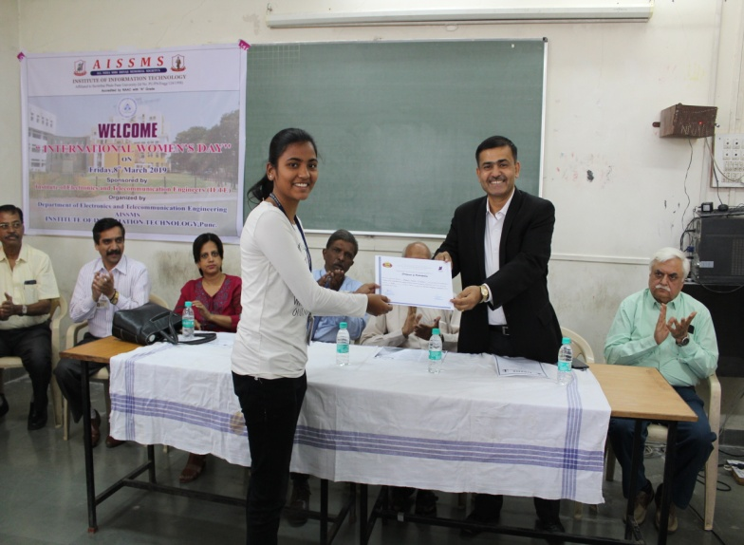
Yoga awareness lecture Cloth Donation
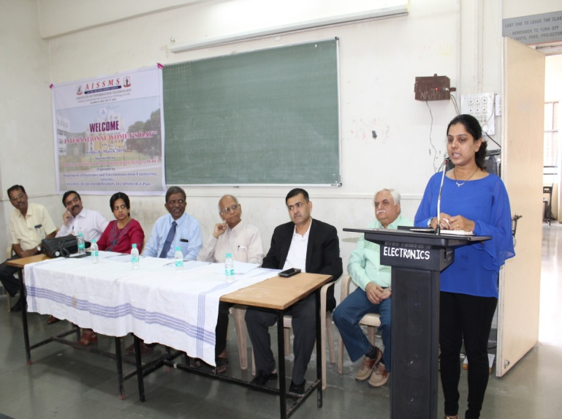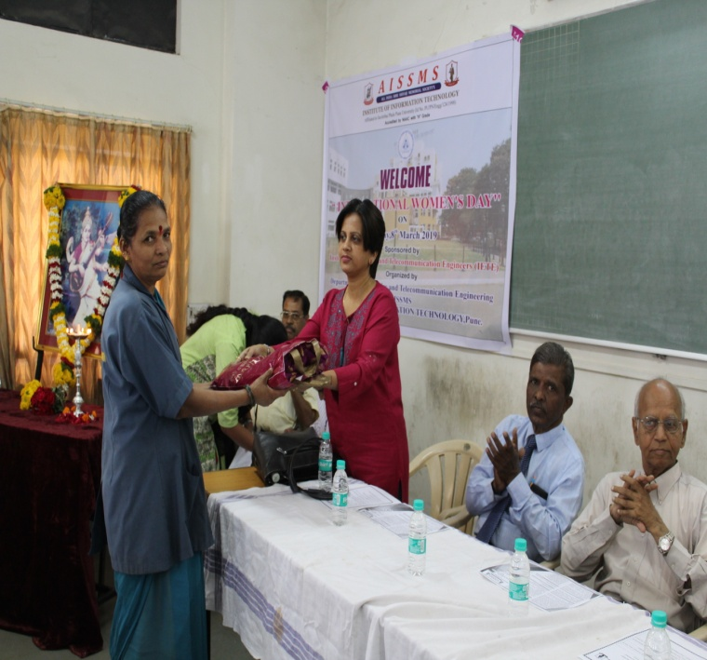

Prof. Geeta D. Salunke Dr. M. P. Sardey
PB Dept. Coordinator PB Coordinator & HoD

