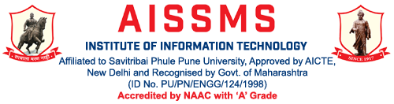
Department of Information Technology

Computer Society of India, Student Chapter
2018-19
Activity Report
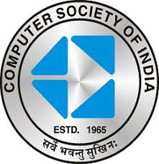

Sr. No | Description of event | Date | Resource Person/  Organization | Participants Class | Coordinated by
1 | Workshop on Latest trends in multithreading and process synchronization issues in OS” | 26/9/18 | Mr. Tushar Kute | TE | Mrs. Anuja Phapale
2 | Workshop on “ Big Data and Hadoop” | 18/01/19 | Mr. Tushar Kute | TE | Mrs. Anuja Phapale
3 | Expert Lecture on BE Project Orientation Program | 13/07/16 | Vivek Aghao | BE | P.A.Patil
4 | Expert Lecture on Big Data and Cloud | 29/08/16 | Deepak Mane | TE | S.P.Badhe
5 | Expert Lecture on Cyber Laws | 01/09/16 | Anubhav Kumar | BE | M.K.Pathak
6 | Expert Lecture on MongoDB | 09/09/16 | Sagar Soni | TE | V.S.More
7 | Data Warehousing | 21/09/16 | Shailaja Bhadgaonkar | TE | A.S.Phapale
8 | Expert Lecture on Android Technology | 27/09/16 | Sameer Awate | BE | P.A.Patil
9 | Expert Lecture on Deep Learning | 28/09/16 | Abhijit Bashetti | BE | R.L.Bhosale
10 | Expert Lecture on BE Project Orientation Program | 19/09/16 | Payal Kakani | BE | P.P.Mahale
11 | Expert Lecture on Web Sevices & Technology | 29/09/16 | Sameer Awate | BE | P.A.Patil
12 | Expert Lecture on Big Data And Hadoop | 4/1/17 | Akshay Bhagwat | TE | S.P.Badhe
13 | Android Technology | 04/01/17 | Dyaneshwar Aghaw | SE | M.K.Pathak
14 | Expert Lecture on Security in Cloud Computing an Salesforce | 06/01/17 | Dyaneshwar Aghaw | TE | M.K.Pathak
15 | Expert Lecture on Security in Cloud Computing an Salesforce | 06/01/17 | Vivek Aghao | BE | M.K.Pathak
16 | Expert Lecture on Centinum Consulting | 04/01/17 | Akshay Bhagwat | BE | P.A.Patil
17 | Expert Lecture on Career Oportunities in Cloud | 06/01/17 | Vivek Aghao | TE, BE | M.K.Pathak
18 | Expert Lecture on Pulse & digital modulation | 20/02/17 | Mandar Karyakarte | SE | Sunanda Kadam
19 | Expert Lecture on Android Installation And Application | 22/2/17 | Manoj Hajare | FE-G,A,D | P.P.Mahale, Sunanda Kadam
20 | Expert Lecture on Enterprise Network Security | 20/03/17 | Yogesh Powar | BE
21 | Expert Lecture on Hibernate | 21/03/17 | Abhijit Bashetti | TE | A.S.Phapale
22 | Expert Lecture on prepaeration for placement in IT industry | 25/03/17 | Sagar Soni | BE | M.K.Pathak
23 | Expert Lecture on prepaeration for placement in IT industry | 25/03/17 | Sagar Soni | TE | M.K.Pathak
24 | Expert Lecture on 8085 Interfacing and applications | 27/03/17 | C.A.Ghuge | SE | R.L.bhosale
25 | Expert Lecture on Animation in Multimedia | 31/03/17 | Nikhil Halli | TE | P.P.Mahale

Glimpses:
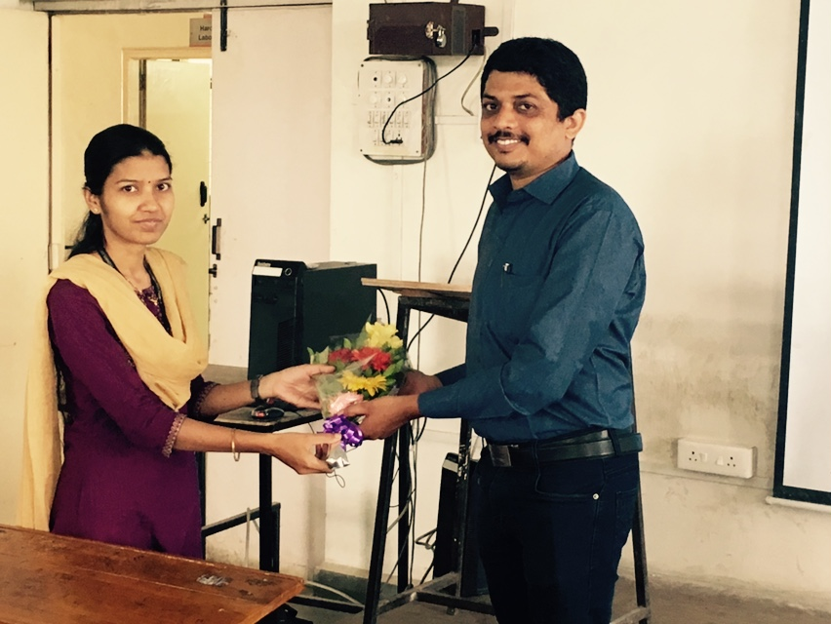
Expert lecture on “ Industry Applications of ML” by Mr.Tushar Kute for BE IT.

