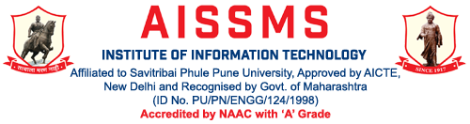
Department of Information Technology

Computer Society of India, Student Chapter
2017-18
Activity Report
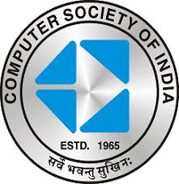

Sr. No | Description of event | Date | Resource Person/  Organization | Participants Class | Coordinated by
1 | Workshop On Technical manuscript preparation with Latex | 24/03/2018 | Mr. Tushar Kute | TE,BE | M.K. Pathak
2 | Seminar On Personality Development | 15/02/2018 | Mr. Sunil Patil | SE | S.S. Chauhan
3 | Seminar On Stress management and Time Management | 29/03/2018 | Mr. Sunil Patil | SE | R. L. Bhosale
4 | Workshop On Hadoop and R Programming | 7/2/2018 | Mr. Tushar Kute | TE | A S Phapale
5 | Expert lecture on “ Programming Foundation with DS” | 2/9/2017 | Mr. Atul Singh | SE | J.C.Pasalkar
6 | Expert lecture on “ Industry Applications of ML” | 17/08/2017 | Mr. Vivek Joshi | BE | R . V. Shinde
7 | Expert lecture on “MongoDB, NoSql Database” | 25/09/2017 | Mr Sagar Soni | TE | V.S. More
8 | Expert lecture on “Practical Approach of using Design Pattern” | 26/09/2017 | Mr Abhijit Bashetti | BE | R . Y. Totare
9 | Expert lecture on “Agile development process” | 11/9/2017 | Mr Parshuram Rathod | TE | P.B. Wakhare
10 | Expert lecture on “Cyber Security and Carrier opportunites Cyber Security” | 8/9/2017 | Mr. Anubhav Kumar Lal | BE | M.K. Pathak
11 | Expert lecture on “Data Sharing: | 16/09/2017 | Mr. Tushar Kute | TE | A S Phapale
12 | Expert lecture on “Advance Java” | 12/7/2017 | Mr. Sandeep Chaodhari | BE | S.P. Bade

Glimpses:
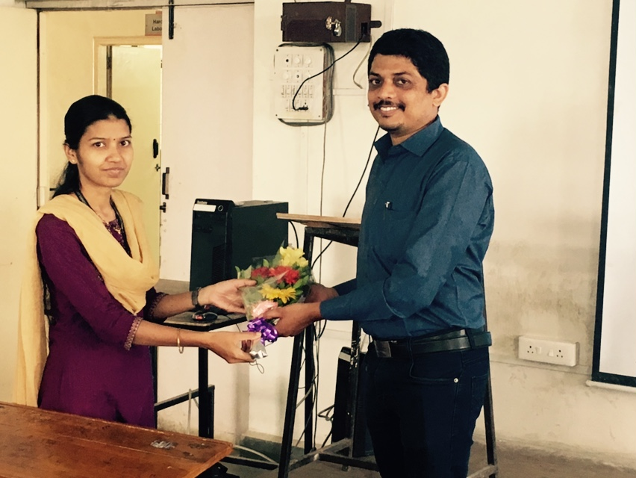
Expert lecture on “ Industry Applications of ML” by Mr.Tushar Kute for BE IT.

