Brief Report of Activities of IEEE Student Branch of AISSMS IOIT, Pune
2020
1. Title of Event : Commercialization Of Quantum Computing Usage On Mass Scale.
2. Category of Event : Technical Event.
3. Date : 11th and 12th Feb 2020.
4. Venue : Multipurpose hall, AISSMS IOIT.
5. Organizer’s Details : AISSMS IOIT, Kennedy Road, Near RTO, Pune.
6. Co-sponsor : IEEE Pune Section.
7. Brief Description of Theme:

Like the blockchain, quantum computing has been one of those technologies that have touted as revolutionary for some time now, promising solutions that may be possible if not readily feasible. Quantum computing has been slowly approaching the commercial sector of IT for about a decade now, with each new generation of quantum-bit (qubit) computers showing more promise in solving actual problems, the kind of problems people pay money to solve.
So the Inside Quantum Technology conference, being held in Boston, positioned itself as the first commercially-oriented quantum computing event, and set out to answer the question of what quantum computing goes in terms of actually generating serious amounts of revenue.
8. Resource- Persons/speaker :
9. Details of Attendees : Total =
IEEE Members :
Guests :
10. Photos :

1. Title of Event : Robo-Tricks
2. Category of Event : Technical event.
3. Date : 17th and 18th Feb 2020.
4. Venue : AISSMS IOIT.
5. Organizer’s Details : AISSMS IOIT, Kennedy Road, Near RTO, Pune.
6. Co-sponsor : IEEE Pune Section.
7. Brief Description of Theme:

Robo-Tricks is a track event. The teams competing have complete the track, clearing all the obstacles. The width of the track is 50cm. The winner is decided on the basis of points which they will earn by completing rounds.
8. Details of Attendees : Total = 129
IEEE Members : 50
Guests : 79
9. Photos :
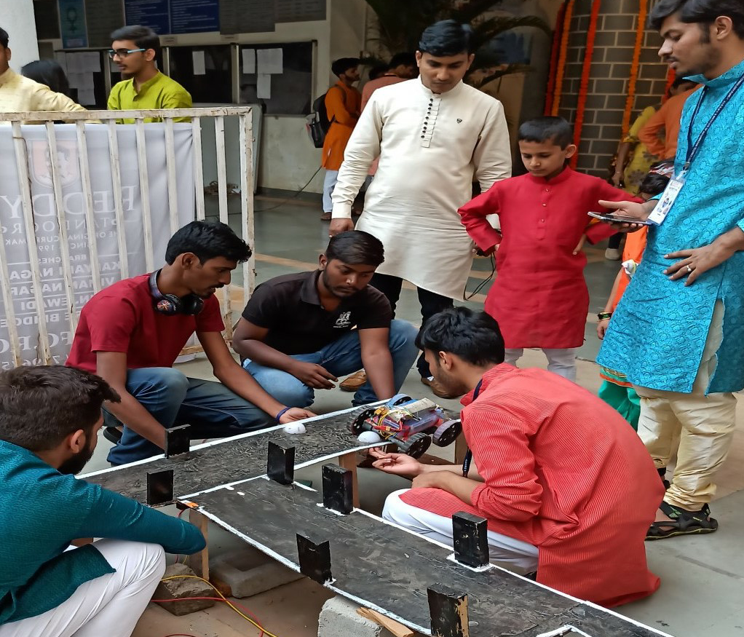

1. Title of Event : Edge Computing- Advancement And Research Opportunities.
2. Category of Event : Technical Event.
3. Date : 17th Feb 2020.
4. Venue : AISSMS IOIT.
5. Organizer’s Details : AISSMS IOIT, Kennedy Road, Near RTO, Pune.
6. Co-sponsor : IEEE Pune Section.
7. Brief Description of Theme:

Edge computing is a distributed computing paradigm which brings computation and data storage closer to the location where it is needed, to improve response times and save bandwidth are discussed in this workshop.
8. Details of Attendees : Total =
IEEE Members :
Guests :
9. Photos :

1. Title of Event : Project Presentation.
2. Category of Event : Technical Event.
3. Date : 17th Feb 2020.
4. Venue : AISSMS IOIT.
5. Organizer’s Details : AISSMS IOIT, Kennedy Road, Near RTO, Pune.
6. Co-sponsor : IEEE Pune Section.
7. Brief Description of Theme:

Participants have to explain their projects with the help of a power point presentation. Participants are also required to bring along a prototype/model or a video of the project.
8. Details of Attendees : Total =80
IEEE Members : 30
Guests : 50
9. Photos :
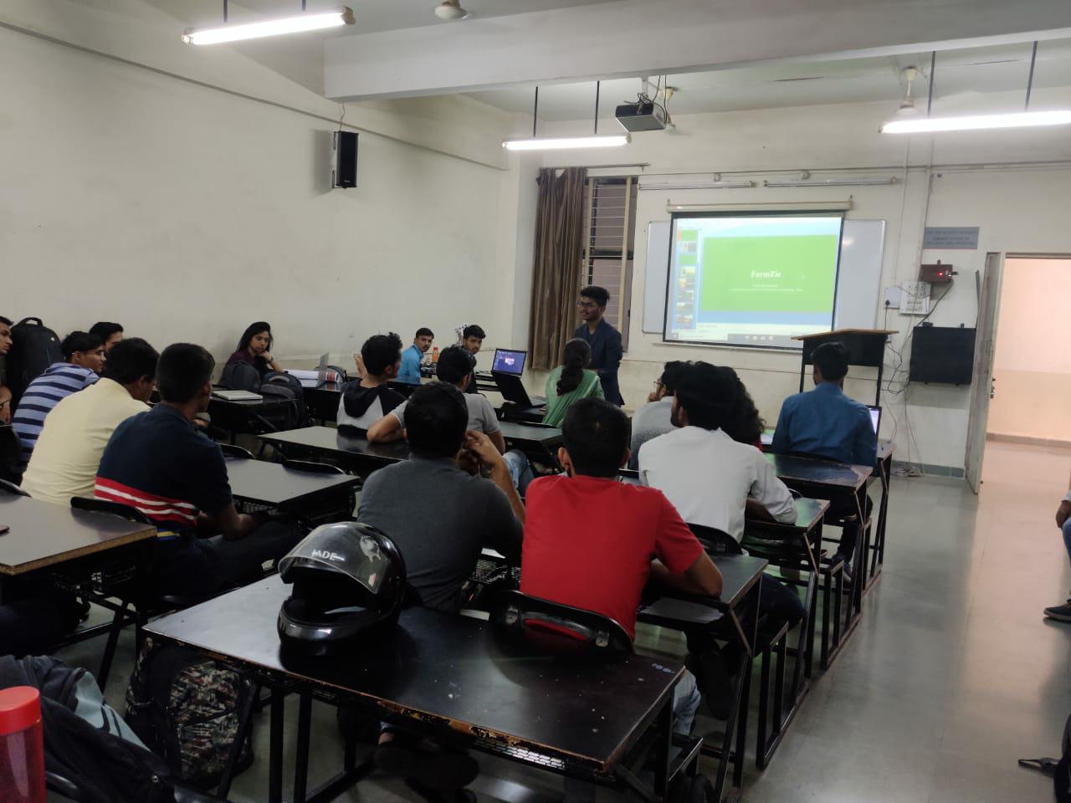

1. Title of Event : Game Of Circuits.
2. Category of Event : Technical Event.
3. Date : 18th Feb 2020.
4. Venue : AISSMS IOIT.
5. Organizer’s Details : AISSMS IOIT, Kennedy Road, Near RTO, Pune.
6. Co-sponsor : IEEE Pune Section.
7. Brief Description of Theme:

Game of circuits is divided in two rounds, the first round is technical aptitude test in which there will be mcqs and the second round will be circuit debugging in which the participants have to debug the given circuit, faulty circuits will be given. Participants have to fix the bug in the circuit in minimum time.
8. Details of Attendees : Total = 169
IEEE Members : 46
Guests : 123
9. Photos :
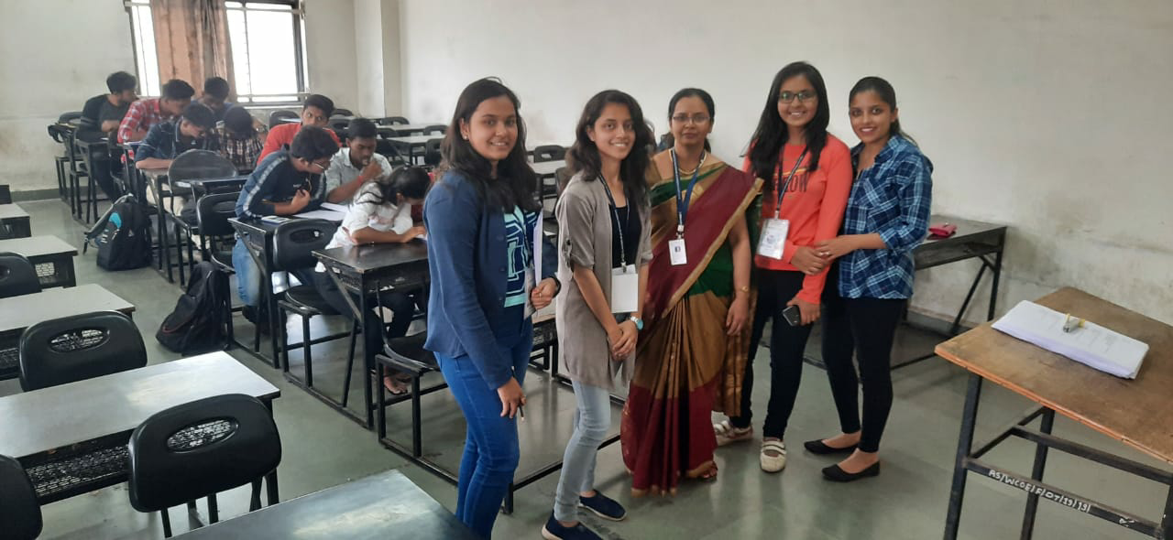

1. Title of Event : Paper Presentation.
2. Category of Event : Technical Event.
3. Date : 19th Feb 2020.
4. Venue : AISSMS IOIT.
5. Organizer’s Details : AISSMS IOIT, Kennedy Road, Near RTO, Pune.
6. Co-sponsor : IEEE Pune Section.
7. Brief Description of Theme:

The participants were asked to e-mail their paper to our email address in the IEEE paper format. And the participants were asked to explain their paper with help of a power point presentation, and they were given approximately 8-10 minutes followed by a Q&A round of 2 minutes on the day of event.
8. Details of Attendees : Total = 34
IEEE Members : 5
Guests : 29
9. Photos :
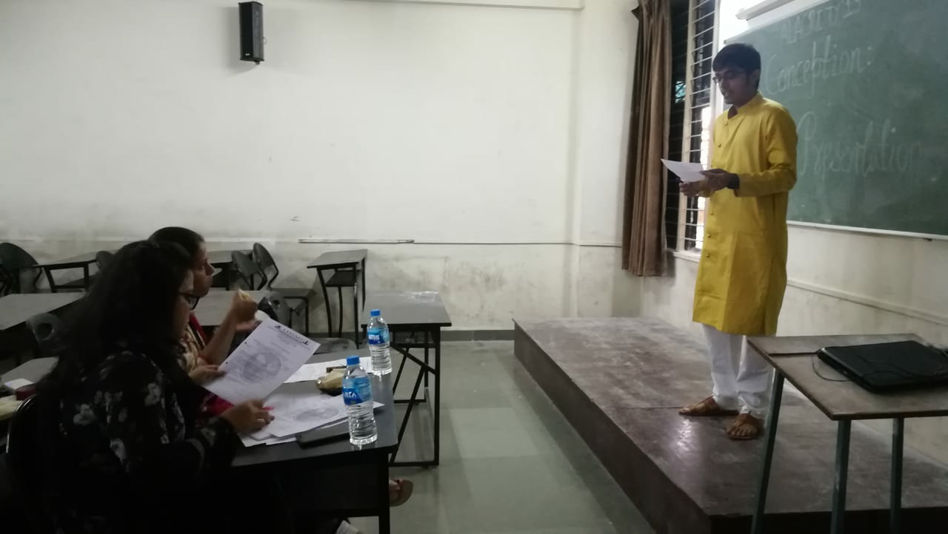

1. Title of Event : Line Tracer.
2. Category of Event : Technical Event.
3. Date : 19th Feb 2020.
4. Venue : AISSMS IOIT.
5. Organizer’s Details : AISSMS IOIT, Kennedy Road, Near RTO, Pune.
6. Co-sponsor : IEEE Pune Section.
7. Brief Description of Theme:

Line tracer was conducted in two rounds. In the first round all robots completing the track within the specified time limit (3 min) will qualify for the next round. In the second round robots are expected to solve the maze while clearing checkpoints in minimum time. Width of the track is 30cm. The track comprises of cuts, curves and turns.
8. Details of Attendees : Total = 58
IEEE Members : 36
Guests : 22
9. Photos :
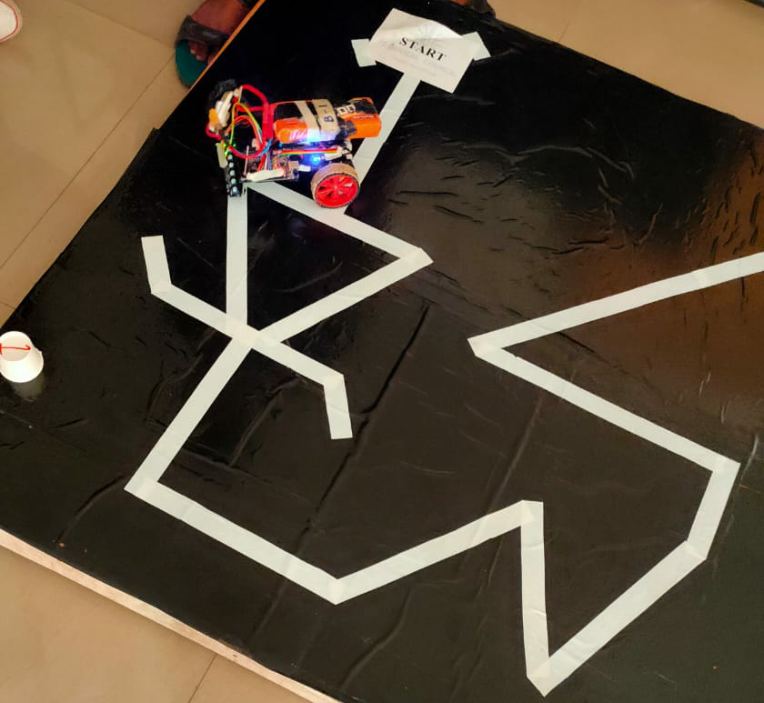

1. Title of Event : IEEE International Conference On Emerging Smart Computing And Informatics.
2. Category of Event : Technical Event.
3. Date : 12th Mar 2020.
4. Venue : Multipurpose hall, AISSMS IOIT.
5. Organizer’s Details : AISSMS IOIT, Kennedy Road, Near RTO, Pune.
6. Co-sponsor : IEEE Pune Section.
7. Brief Description of Theme:

The conference mainly focuses toward the emerging techniques required for smart computing and informatics. This conference aims to present a unifiled platform for advanced and multi- disciplinary research towards design of smart computing and informatics. objective of conference is to encourage students in the prepration of better technical paper in the filed of engineering and technology.
8. Details of Attendees : Total = 57
IEEE Members : 25
Guests : 32
9. Photos :

1. Title of Event : ESCI – Network And Communication Track.
2. Category of Event : Technical Event.
3. Date : 12th Mar 2020.
4. Venue : Multipurpose hall, AISSMS IOIT.
5. Organizer’s Details : AISSMS IOIT, Kennedy Road, Near RTO, Pune.
6. Co-sponsor : IEEE Pune Section.
7. Brief Description of Theme:

The 2nd International Conference on Emerging Smart Computing and Informatics (ESCI-2020) is the platform where academics and industry researchers present their latest algorithms, models and technologies and explore new trends and ideas on smart computing and informatics. The aim of this conference is to provide an allied platform for emerging trends in smart computing, networking, communication, signal and image processing, cyber security and IOT. The key intention is to provide opportunity for the global participants to share their ideas and experiences in person with their peers expected to join from different parts of the world. In addition to this, the gathering will help the delegates to establish research environment as well as to find the international linkage for future collaboration in their career path. The conference focuses on various modernization and innovation paradigms that may be applied to present practical and creative solutions to diverse issues in society, industry and environment. The conference proceeding invites academics and industry researchers for publication of papers explaining literature review, problem statement, methodologies with appropriate results. The selected papers will be sent to the experts for review. Acceptance will be based on significant and innovative content, originality and unpublished quality work. Accepted and presented papers will be published in IEEE Explore digital library. The Conference also invites special topics, tools and applications in multidisciplinary areas with workshops, tutorial sessions by expert academicians and professionals.
8. Details of Attendees : Total = 75
IEEE Members : 19
Guests : 56
9. Photos :
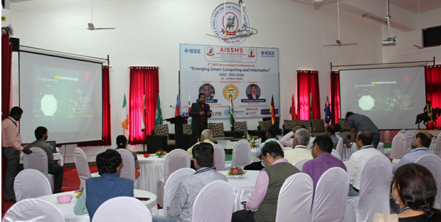

1. Title of Event : ESCI – Smart Computing Track.
2. Category of Event : Technical Event.
3. Date : 12th Mar 2020.
4. Venue : Multipurpose hall, AISSMS IOIT.
5. Organizer’s Details : AISSMS IOIT, Kennedy Road, Near RTO, Pune.
6. Co-sponsor : IEEE Pune Section.
7. Brief Description of Theme:

The 2nd International Conference on Emerging Smart Computing and Informatics (ESCI-2020) is the platform where academics and industry researchers present their latest algorithms, models and technologies and explore new trends and ideas on smart computing and informatics. The aim of this conference is to provide an allied platform for emerging trends in smart computing, networking, communication, signal and image processing, cyber security and IOT. The key intention is to provide opportunity for the global participants to share their ideas and experiences in person with their peers expected to join from different parts of the world. In addition to this, the gathering will help the delegates to establish research environment as well as to find the international linkage for future collaboration in their career path. The conference focuses on various modernization and innovation paradigms that may be applied to present practical and creative solutions to diverse issues in society, industry and environment. The conference proceeding invites academics and industry researchers for publication of papers explaining literature review, problem statement, methodologies with appropriate results. The selected papers will be sent to the experts for review. Acceptance will be based on significant and innovative content, originality and unpublished quality work. Accepted and presented papers will be published in IEEE Explore digital library. The Conference also invites special topics, tools and applications in multidisciplinary areas with workshops, tutorial sessions by expert academicians and professionals.

8. Details of Attendees : Total = 52
IEEE Members : 10
Guests : 42
9. Photos :
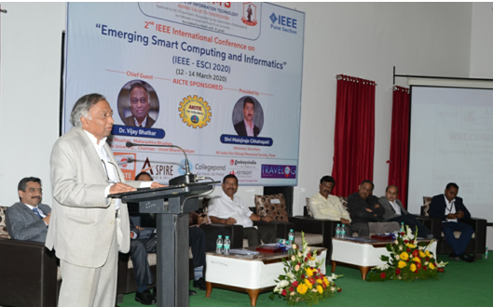

1. Title of Event : ESCI – Image And Signal Processing Track.
2. Category of Event : Technical Event.
3. Date : 13th Mar 2020.
4. Venue : AISSMS IOIT.
5. Organizer’s Details : AISSMS IOIT, Kennedy Road, Near RTO, Pune.
6. Co-sponsor : IEEE Pune Section.
7. Brief Description of Theme:

The 2nd International Conference on Emerging Smart Computing and Informatics (ESCI-2020) is the platform where academics and industry researchers present their latest algorithms, models and technologies and explore new trends and ideas on smart computing and informatics. The aim of this conference is to provide an allied platform for emerging trends in smart computing, networking, communication, signal and image processing, cyber security and IOT. The key intention is to provide opportunity for the global participants to share their ideas and experiences in person with their peers expected to join from different parts of the world. In addition to this, the gathering will help the delegates to establish research environment as well as to find the international linkage for future collaboration in their career path. The conference focuses on various modernization and innovation paradigms that may be applied to present practical and creative solutions to diverse issues in society, industry and environment. The conference proceeding invites academics and industry researchers for publication of papers explaining literature review, problem statement, methodologies with appropriate results. The selected papers will be sent to the experts for review. Acceptance will be based on significant and innovative content, originality and unpublished quality work. Accepted and presented papers will be published in IEEE Explore digital library. The Conference also invites special topics, tools and applications in multidisciplinary areas with workshops, tutorial sessions by expert academicians and professionals.

8. Details of Attendees : Total = 44
IEEE Members : 5
Guests : 39
9. Photos :
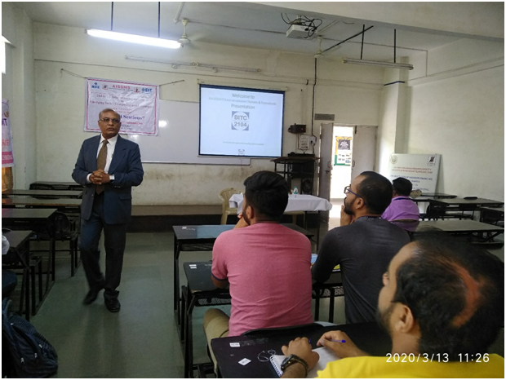

1. Title of Event : Tutorial Session On Industrial Automation.
2. Category of Event : Technical Event.
3. Date : 13th Mar 2020.
4. Venue : AISSMS IOIT.
5. Organizer’s Details : AISSMS IOIT, Kennedy Road, Near RTO, Pune.
6. Co-sponsor : IEEE Pune Section.
7. Brief Description of Theme:

Resource person explained about what actually industrial automation is all about and journey till Industry 4.0. Industrial automation is the use of control systems, such as computers or robots, and information technologies for handling different processes and machineries in an industry to replace a human being. It is the second step beyond mechanization in the scope of industrialization. Advantages of Industrial Automation were discussed. Various automation examples were also given and explained.

8. Details of Attendees : Total = 55
IEEE Members : 10
Guests : 45
9. Photos :

1. Title of Event : ESCI – Cyber Security Track.
2. Category of Event : Technical Event.
3. Date : 14th Mar 2020.
4. Venue : AISSMS IOIT.
5. Organizer’s Details : AISSMS IOIT, Kennedy Road, Near RTO, Pune.
6. Co-sponsor : IEEE Pune Section.
7. Brief Description of Theme:

The 2nd International Conference on Emerging Smart Computing and Informatics (ESCI-2020) is the platform where academics and industry researchers present their latest algorithms, models and technologies and explore new trends and ideas on smart computing and informatics. The aim of this conference is to provide an allied platform for emerging trends in smart computing, networking, communication, signal and image processing, cyber security and IOT. The key intention is to provide opportunity for the global participants to share their ideas and experiences in person with their peers expected to join from different parts of the world. In addition to this, the gathering will help the delegates to establish research environment as well as to find the international linkage for future collaboration in their career path. The conference focuses on various modernization and innovation paradigms that may be applied to present practical and creative solutions to diverse issues in society, industry and environment. The conference proceeding invites academics and industry researchers for publication of papers explaining literature review, problem statement, methodologies with appropriate results. The selected papers will be sent to the experts for review. Acceptance will be based on significant and innovative content, originality and unpublished quality work. Accepted and presented papers will be published in IEEE Explore digital library. The Conference also invites special topics, tools and applications in multidisciplinary areas with workshops, tutorial sessions by expert academicians and professionals.
8. Details of Attendees : Total = 63
IEEE Members : 13
Guests : 50
9. Photos :

1. Title of Event : ESCI – IoT And Automation Track.
2. Category of Event : Technical Event.
3. Date : 15th Mar 2020.
4. Venue : AISSMS IOIT.
5. Organizer’s Details : AISSMS IOIT, Kennedy Road, Near RTO, Pune.
6. Co-sponsor : IEEE Pune Section.
7. Brief Description of Theme:

The 2nd International Conference on Emerging Smart Computing and Informatics (ESCI-2020) is the platform where academics and industry researchers present their latest algorithms, models and technologies and explore new trends and ideas on smart computing and informatics. The aim of this conference is to provide an allied platform for emerging trends in smart computing, networking, communication, signal and image processing, cyber security and IOT. The key intention is to provide opportunity for the global participants to share their ideas and experiences in person with their peers expected to join from different parts of the world. In addition to this, the gathering will help the delegates to establish research environment as well as to find the international linkage for future collaboration in their career path. The conference focuses on various modernization and innovation paradigms that may be applied to present practical and creative solutions to diverse issues in society, industry and environment. The conference proceeding invites academics and industry researchers for publication of papers explaining literature review, problem statement, methodologies with appropriate results. The selected papers will be sent to the experts for review. Acceptance will be based on significant and innovative content, originality and unpublished quality work. Accepted and presented papers will be published in IEEE Explore digital library. The Conference also invites special topics, tools and applications in multidisciplinary areas with workshops, tutorial sessions by expert academicians and professionals.
8. Details of Attendees : Total = 74
IEEE Members : 15
Guests : 59
9. Photos :
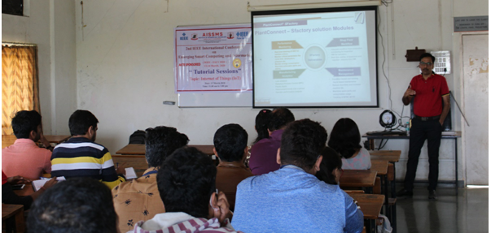

1. Title of Event : Artificial Intelligence In Health Care Sector.
2. Category of Event : Technical Event.
3. Date : 20th Mar 2020.
4. Venue : AISSMS IOIT.
5. Organizer’s Details : AISSMS IOIT, Kennedy Road, Near RTO, Pune.
6. Co-sponsor : IEEE Pune Section.
7. Brief Description of Theme:

Artificial intelligence (AI) in healthcare is the use of complex algorithms and software to emulate human cognition in the analysis of complicated medical data. Specifically, AI is the ability for computer algorithms to approximate conclusions without direct human input.
What distinguishes AI technology from traditional technologies in health care is the ability to gain information, process it and give a well-defined output to the end-user. AI does this through machine learning algorithms. These algorithms can recognize patterns in behaviour and create its own logic. In order to reduce the margin of error, AI algorithms need to be tested repeatedly. AI algorithms behave differently from humans in two ways: (1) algorithms are literal: if you set a goal, the algorithm can't adjust itself and only understand what it has been told explicitly, and algorithms are black box.
8. Details of Attendees : Total =
IEEE Members :
Guests :
9. Photos :

1. Title of Event : Data Structure And Algorithms.
2. Category of Event : Technical Event.
3. Date : 1st Apr 2020.
4. Venue : AISSMS IOIT.
5. Organizer’s Details : AISSMS IOIT, Kennedy Road, Near RTO, Pune.
6. Co-sponsor : IEEE Pune Section.
7. Brief Description of Theme:

This is one of the important subject of computer and it students. Students didn't know how to use this algorithms in projects so they just learned this for examination. Under this workshop we are going to cover how-to implement this algorithms and data structures in projects.
8. Details of Attendees : Total =
IEEE Members :
Guests :
9. Photos :

1. Title of Event : Data Structure Quiz.
2. Category of Event : Technical Event.
3. Date : 25th May 2020.
4. Venue : Pune, Maharashtra.
5. Organizer’s Details : AISSMS IOIT, Kennedy Road, Near RTO, Pune.
6. Co-sponsor : IEEE Pune Section.
7. Brief Description of Theme: Technical Quiz

8. Details of Attendees : Total = 278
IEEE Members : 101
Guests : 177
9. Photos :

1. Title of Event : Digital Poster Competition.
2. Category of Event : Technical Event.
3. Date : 30th May 2020.
4. Venue : Pune, Maharashtra.
5. Organizer’s Details : AISSMS IOIT, Kennedy Road, Near RTO, Pune.
6. Co-sponsor : IEEE Pune Section.
7. Brief Description of Theme:

Department of Computer Engineering organized an event of Digital Poster Competition. The topics were A)Future of education, B)Can artificial intelligence help in pandemic, C)Solutions for living with Covid-19, D)How lockdown affected society. The event was organized by Mr. Abhishek Agarwal and Ms. Gauri Wagholikar, IEEE Department student coordinators, Mrs. M .A. Zope and Mrs. P. S. Gaikwad, faculty coordinator under guidance of Dr. S. N. Zaware, HOD, Computer Engineering Dept, AISSMS’s IOIT.

8. Details of Attendees : Total = 63
IEEE Members : 15
Guests : 48
9. Photos :

1. Title of Event : Online Quiz On “ Industrial Automation ”.
2. Category of Event : Technical Event.
3. Date : 30th May 2020.
4. Venue : Pune, Maharashtra.
5. Organizer’s Details : AISSMS IOIT, Kennedy Road, Near RTO, Pune.
6. Co-sponsor : IEEE Pune Section.
7. Brief Description of Theme:

Department of Instrumentation Engineering organized online quiz on Industrial Automation. The participants scoring more than 60% received E- Certificates. This Quiz was organized only for students.The event was organized by Mr. Aditya Baradkar, IEEE Department student coordinator, Mrs. V. V. Kale, faculty coordinator under guidance of Dr. D. R. Shende, HOD, Instrumentation Engg Dept, AISSMS’s IOIT.
8. Details of Attendees : Total = 604
IEEE Members : 450
Guests : 154
9. Photos :
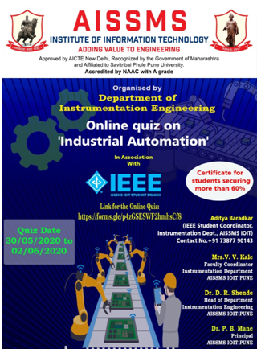

1. Title of Event : Webinar On “ Career Guidance ”.
2. Category of Event : Technical Event.
3. Date : 20th Aug 2020.
4. Venue : Google Meet.
5. Organizer’s Details : AISSMS IOIT, Kennedy Road, Near RTO, Pune.
6. Co-sponsor : IEEE Pune Section.
7. Brief Description of Theme:

Ms. Amolika Bhonsle was the keynote speaker for this webinar. She is an alumna of 2014 batch. The webinar was filled with interesting experiences from her under-graduation and post-graduation years. All those experiences comprised of note-worthy tips and tricks for students from all branches to take away. The webinar was very interactive, descriptive, thoughtful and proved to be an eye opener for the students who had clogged their mind with several doubts along these lines. During the webinar, students asked quite intuitive and thought-provoking questions. Ms. Amolika was phenomenal throughout the webinar and her responses were crisp and on-point. All in all the webinar proved to be a giant success and it will definitely help the students in their future endeavors.
8. Details of Attendees : Total = 392
IEEE Members : 42
Guests : 350
9. Photos :
