Brief Report of Activities of IEEE Student Branch of AISSMS IOIT, Pune
2018

1. Title of Event :Energy Audit For Banking Sector.
2. Category of Event :Technical Event.
3. Day, Date :1st Aug 2018.
4. Venue :Multipurpose HALL and all departments, AISSMS IOIT.
5. Organizer’s Details :AISSMS IOIT, Kennedy Road, Near RTO, Pune
6. Co-sponsor :IEEE Pune Section.
7. Brief Description of Theme:
Ongoing Techno Social Activity for budding Engineer(students), faculty and consultants introduced this year.Students walk through the bank quickly and study load pattern, working pattern, metering, billing. Note down voltage, current, power backup, working schedule, Energy Utilization pattern etc.Suggestions are given to minimize energy consumption without affecting the working. If necessary a detailed study is advised.127 bank branches are covered by 25 students during Aug, Sep 2018. 400+ branches will be covered up-to Nov by 75 more students.

8. Details of Attendees : Total = 75
IEEE Members : 5
Guests : 70
9. Photos :

Brief Report of Activities of IEEE Student Branch of AISSMS IOIT, Pune
2019
1. Title of Event :Zenith-2019.
2. Category of Event :Technical Event.
3. Day, Date :1st Feb 2019
4. Venue :Multipurpose HALL and all departments, AISSMS IOIT.
5. Organizer’s Details : AISSMS IOIT, Kennedy Road, Near RTO, Pune
6. Co-sponsor :IEEE Pune Section.
7. Brief Description of Theme:

One Day workshop on MATLAB &SIMULINK
- Basics for the Budding Engineer in Electrical Engineering:
- Electrical/Electronic simulation using Simscape
- Electrical engineering using Sim Power systems
- Signal Processing
- Design and simulation of circuits
- Control System Design
- Going from simulation to Implementation on embedded systems (Arduino, RaspberryPi& TI)
- Physical Demos:
- Demo of Magnetic levitation system
- Motor speed and position control

8. Resource- Persons/speaker :Direndra Singh, Application Engineering,
MathWorks, Bangalore.
9. Topics covered in short : Technical Quiz in domain of electrical, Poster on theme Digital India, Project, Model Competition, C code generation and Circuit design.
10. Details of Attendees : Total = 17
IEEE Members : 12
Guests : 5
11. Photos :

1. Title of Event :Conference on ML for Data Science &IoT.
2. Category of Event :Technical Event.
3. Day, Date :8th Feb 2019.
4. Venue :Multipurpose HALL and all departments, AISSMS IOIT.
5. Organizer’s Details :AISSMS IOIT, Kennedy Road, Near RTO, Pune
6. Co-sponsor :IEEE Pune Section.
7. Brief Description of Theme:
The conference mainly focuses toward the emerging techniues on Machine Learning for Data Science and Internet of Things(IOT). This conference aims to present a unified platform for advanced and multi- disciplinary research towards Machine Learning. Objective of conference is to encourage students in the prepration of better technical paper in the filed of engineering and technology.

8. Details of Attendees : Total =
IEEE Members :
Guests :
9. Photos :

1. Title of Event :Alacrity’19 Hackathon&Makeathon.
2. Category of Event :Technical Event.
3. Day, Date :9th Feb 2019.
4. Venue :Multipurpose HALL and all departments, AISSMS IOIT.
5. Organizer’s Details : AISSMS IOIT, Kennedy Road, Near RTO, Pune
6. Co-sponsor :IEEE Pune Section.
7. Brief Description of Theme:
A Problem statement will be provided, and the Team has to work on it. There can be minimum 2 and maximum 5 members in a team. Internet and Wi-Fi connectivity will be provided throughout the event. All the members should be present during the event to succesfully participate in the event. App development/Website can be done as per the project guidelines.

8. Details of Attendees : Total =
IEEE Members :
Guests :
9. Photos :
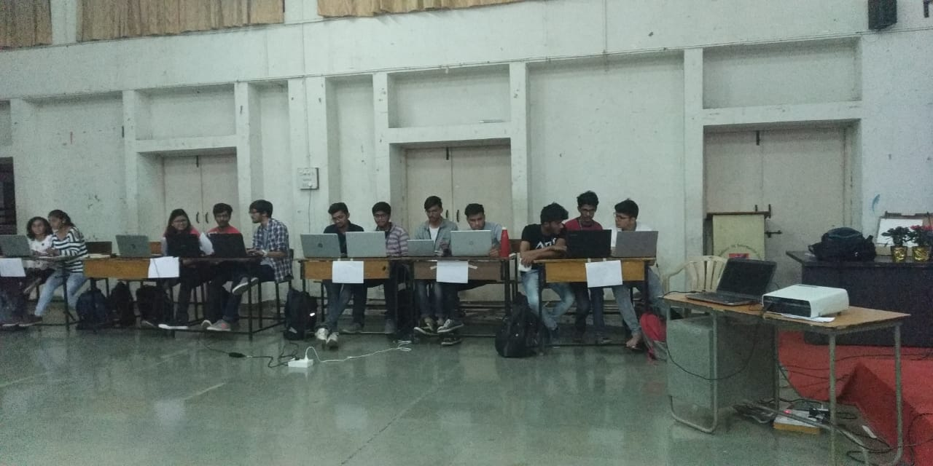

1. Title of Event :Robo-tricks.
2. Category of Event :Technical Event.
3. Day, Date :14th Feb 2019.
4. Venue :AISSMS IOIT.
5. Organizer’s Details : AISSMS IOIT, Kennedy Road, Near RTO, Pune
6. Co-sponsor :IEEE Pune Section.
7. Brief Description of Theme:
Robo-tricks is track event. The teams competing have to complete the track, clearing all the obstacles. The width of the track is 50cm. the winner is decided on the basis ofpoints which they will earn by com[letting rounds.
8. Details of Attendees : Total =
IEEE Members :
Guests :
9. Photos :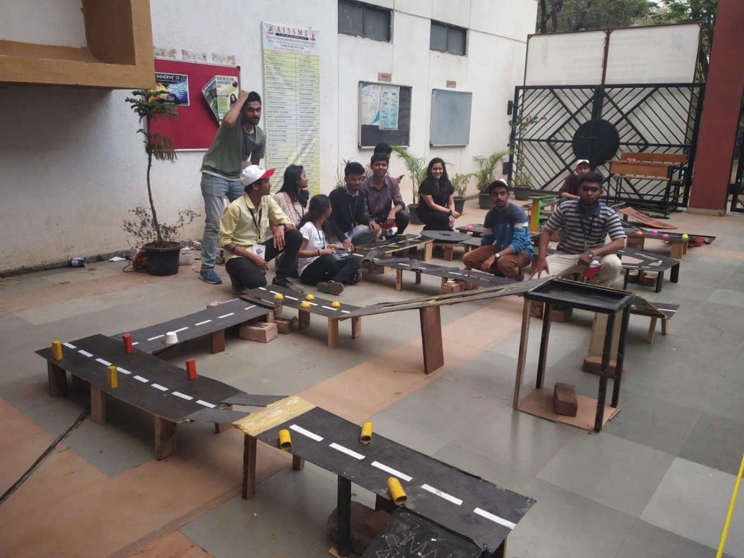

1. Title of Event :Techiton.
2. Category of Event :Technical Event.
3. Day, Date :15th Feb 2019.
4. Venue :Multipurpose hall,AISSMS IOIT.
5. Organizer’s Details : AISSMS IOIT, Kennedy Road, Near RTO, Pune
6. Co-sponsor :IEEE Pune Section.
7. Brief Description of Theme:
A 24 HrsTechiton i.e. Hakathon were organised. On the spot problem statements were provided and students were supposed to do it in 24 Hrs. A cash prize of 10000Rs were awarded to Winner.

8. Details of Attendees : Total = 19
IEEE Members : 15
Guests : 4
9. Photos :

1. Title of Event :Paper Presentation.
2. Category of Event :Technical Event.
3. Day, Date :18th Feb 2019.
4. Venue :AISSMS IOIT.
5. Organizer’s Details : AISSMS IOIT, Kennedy Road, Near RTO, Pune
6. Co-sponsor :IEEE Pune Section.
7. Brief Description of Theme:
The Participant has to explain his/her Paper with the help of PPT. The soft copy of presentation and paper must be brought on the day of competition in a flash drive. Paper must be in .docx format and presentation must be in .pptx format. The presentation should have a minimum duration of 8 to 10 minutes.

8. Details of Attendees : Total =
IEEE Members :
Guests :
9. Photos :

1. Title of Event :Drone Challenge.
2. Category of Event :Technical Event.
3. Day, Date :20th Feb 2019.
4. Venue :AISSMS IOIT.
5. Organizer’s Details : AISSMS IOIT, Kennedy Road, Near RTO, Pune
6. Co-sponsor :IEEE Pune Section.
7. Brief Description of Theme:
There will be 3 Rounds which comprises set of tasks to be completed by the Drone. The Drone should have minimum dimensions of 55cm*55cm*55cm. Points will be given on the basis of completion and Time taken. Automated and High End Drones are not allowed.

8. Details of Attendees : Total =
IEEE Members :
Guests :
9. Photos :
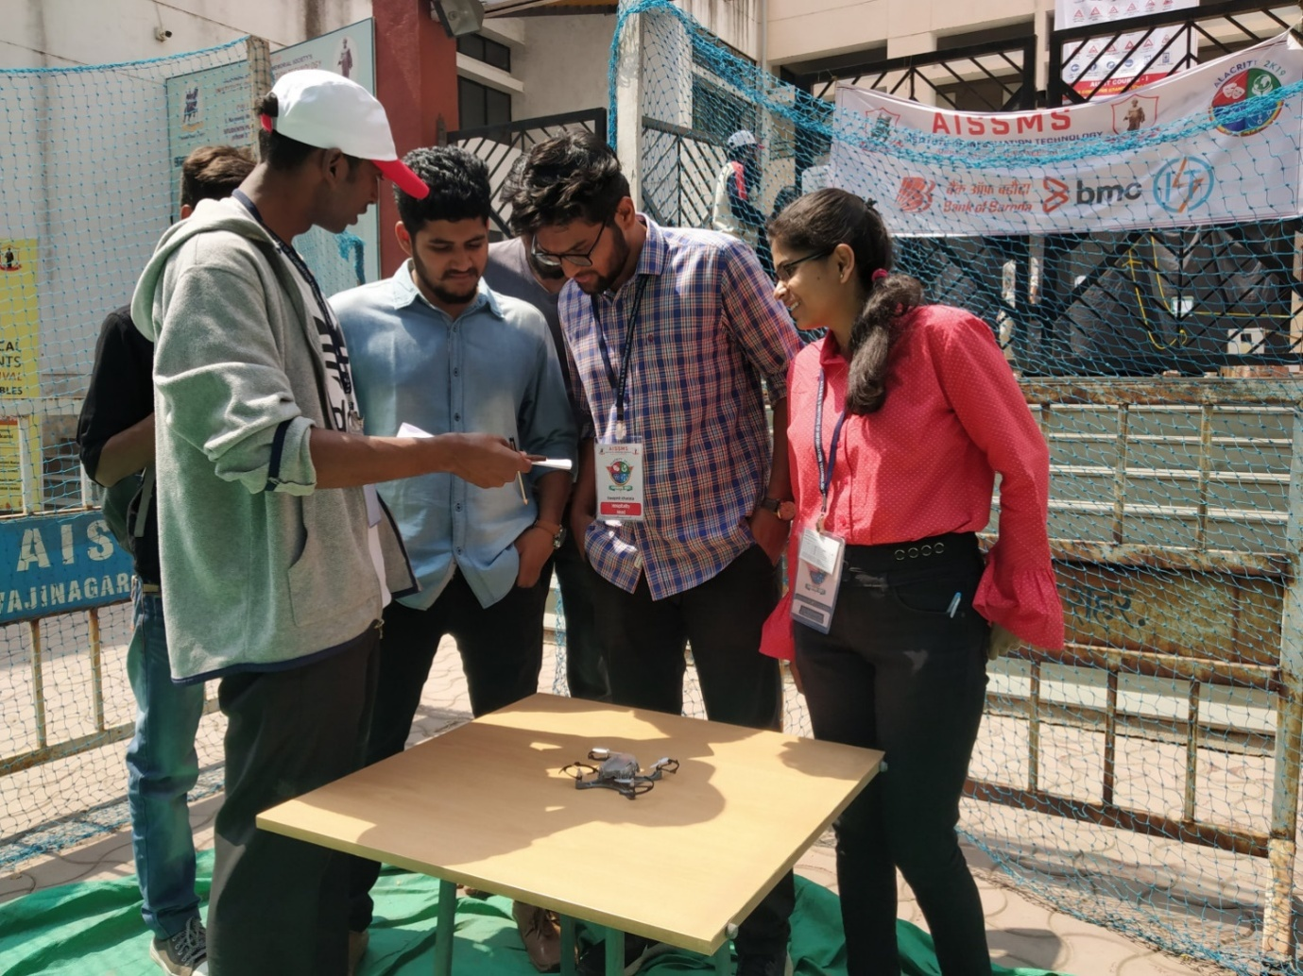

1. Title of Event :Two Days Workshop on “Intellectual Property Rights: Role in Make In India”.
2. Category of Event :Technical Event.
3. Day, Date :18th Mar 2019.
4. Venue :AISSMS IOIT.
5. Organizer’s Details : AISSMS IOIT, Kennedy Road, Near RTO, Pune
6. Co-sponsor :IEEE Pune Section.
7. Brief Description of Theme:
First day, first session started with the keynote speech of Dr.ApurvaPalkar by highlighting what innovation is and how to convert innovative idea into startup. She shared some successful stories of startups and introduced role of government in startup. She also explored "Centre for Innovation,Incubation& Linkage schemes for students and faculties, started by SPPU, Pune University.
First day, second session was conducted by Dr. V. K. Bairagi on copyright and types of IPR. He gave guidelines for copyright and history of copyright, followed by the different types and the dual role played by copyrights were discussed. The talk gave a clear idea about the different rights granted by copyright such as the economic and moral rights. The session also gave an idea about the section 52 of the copyright law and different types of IPR.

8. Details of Attendees : Total = 40
IEEE Members : 25
Guests : 15
9. Photos :

1. Title of Event :IEEE Project Competition.
2. Category of Event :Technical Event.
3. Day, Date :4th Jun 2019.
4. Venue :AISSMS IOIT.
5. Organizer’s Details : AISSMS IOIT, Kennedy Road, Near RTO, Pune
6. Co-sponsor :IEEE Pune Section.
7. Brief Description of Theme:
This Event was a platform for Students to display their projects. Some major projects of this event were Seed Sower, Solar Energy Harvester, Grasscutter and many more intresting projects. Many students from different Colleges also participated in this event.
Project Competition for UG/PG students,
(Signal Processing and Communications domain)

8. Details of Attendees : Total = 13
IEEE Members : 10
Guests : 3
9. Photos :

1. Title of Event :Nagar Road Visit.
2. Category of Event :Technical Event.
3. Day, Date :27th July 2019.
4. Venue :Ahmednagar, Pune.
5. Organizer’s Details : AISSMS IOIT, Kennedy Road, Near RTO, Pune
6. Co-sponsor :IEEE Pune Section.
7. Brief Description of Theme:
We Visited to the Farm of Mr.Nalawade near Ahmednagar Road. Our main purpose of this event was to test the Projects like Seed sawer, Grasscutter, Drumstick cutter on field and how they can help Farmers. While this event the Farmers informed us about a Plant for disposal of Cowdung and converting it into Fertilizers present in their Village.

8. Details of Attendees : Total =
IEEE Members :
Guests :
9. Photos :

1. Title of Event :Guest Lecture by Mr. DinanathKholkar& Inauguration of HAC Labortary.
2. Category of Event :Technical Event.
3. Day, Date :30th Aug 2019.
4. Venue :AISSMS, IOIT.
5. Organizer’s Details : AISSMS IOIT, Kennedy Road, Near RTO, Pune
6. Co-sponsor :IEEE Pune Section.
7. Brief Description of Theme:
Mr.DinanathKholkar briefed us in his lecture about how we can Improve the Life of Farmers with our technical knowledge. He also motivated us to make Real Life based Projects.
HAC Lab - HUMANITARIAN ACTIVITY COMMITTEE LABORATORY. Inaugration of the HAC lab was done by Dr.DinanathKholkar, Global Head of the Analytics & Insights unit of Tata Consultancy Services (TCS). Texas instruments and over 20 projects were displayed during this Inaugration.
8. Details of Attendees : Total =
IEEE Members :
Guests :
9. Photos :
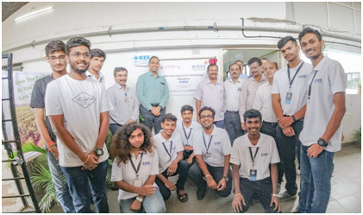

1. Title of Event :Trident 4.0.
2. Category of Event :Technical Event.
3. Day, Date :20th Sept 2019.
4. Venue :AISSMS, IOIT.
5. Organizer’s Details : AISSMS IOIT, Kennedy Road, Near RTO, Pune
6. Co-sponsor :IEEE Pune Section.
7. Brief Description of Theme:
Trident 4.0 was a 2 days Hackathon. Trident was organiszed by Four Institutes:- AISSMS IOIT,AISSMS COE, SYMBIOSIS, GH RAISONI WAGHOLI. The winners of this Trident Hackathon were from AISSMS IOIT.
8. Details of Attendees : Total =
IEEE Members :
Guests :
9. Photos :

1. Title of Event :Workshop on AI and DL &IoT- Arduino, Sensors/ Microcontrollers.
2. Category of Event :Technical Event.
3. Day, Date :30th Sept 2019.
4. Venue :AISSMS, IOIT.
5. Organizer’s Details : AISSMS IOIT, Kennedy Road, Near RTO, Pune
6. Co-sponsor :IEEE Pune Section.
7. Brief Description of Theme:
A 3 days workshop on Artificial Intelligence(AI) and Deep Learning(DL) for students of IT and Computer Branch. The workshop covered many of the topics that will be helpful for the students and also covered some topics of Machine Learning(ML).
A 2 days workshop on Internet Of Things. This workshop was for Arduino& Sensors. This was a Hands-on workshop, some sensors were provided from the college whereas some students brought their own sensors and Arduino.
8. Details of Attendees : Total =
IEEE Members :
Guests :
9. Photos :

1. Title of Event :PCB Designing Workshop.
2. Category of Event :Technical Event.
3. Day, Date :20th Nov 2019.
4. Venue :AISSMS, IOIT.
5. Organizer’s Details : AISSMS IOIT, Kennedy Road, Near RTO, Pune
6. Co-sponsor :IEEE Pune Section.
7. Brief Description of Theme:
In our college AISSMS IOIT, we have PCB Designing machine. During this workshop, the Students of EnTC department were given the practical knowledge on PCB designing. This workshop will help the students so that they can easily build the PCB design of their projects.
8. Details of Attendees : Total =
IEEE Members :
Guests :
9. Photos :

