Brief Report of Activities of IEEE Student Branch of AISSMS IOIT, Pune
2017

1. Title of Event : Zenith-2017
2. Category of Event : Technical Competitions
3. Day, Date : 23rd , 24th August and 15th Sept. 2017
4. Venue : Multipurpose HALL and all departments, AISSMS IOIT,
Kennedy Road, Near RTO, Pune
5. Organizer’s Details : AISSMS IOIT, Kennedy Road, Near RTO, Pune
6. Co-sponsor : IEEE Pune Section.
7. Brief Description of Theme:

To provide common platform for students of all departments of IOIT and to give wide opportunities to all students for developing their qualities various competitions were organized. Competitions were based on themes like digital India, Global warming, new technologies in industries, save earth, etc. Dr. Arvind Saligram, Registrar, SPPU, Pune was the chief guest for
valedictory function.

8. Resource- Persons/speaker : Dr.Arvind Digambar Shaligram
Registrar, SPPU, Pune
9. Topics covered in short : Technical Quiz in domain of electrical, Poster on theme Digital India, Project, Model Competition, C code generation and Circuit design.
10. Details of Attendees : Total = 607
IEEE Members : 10
Students (UG, PG, PhD) : 597
Industry :
Academics :
Consultants :

12. Photos :
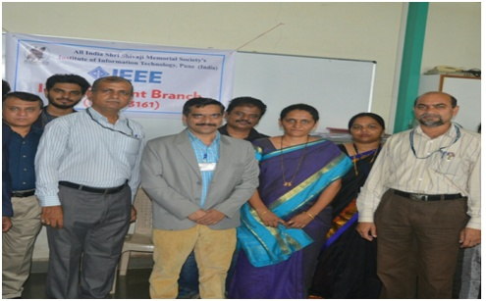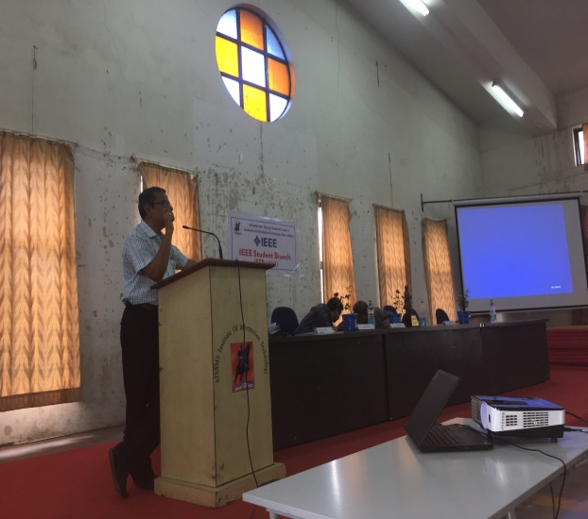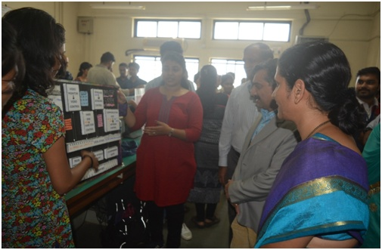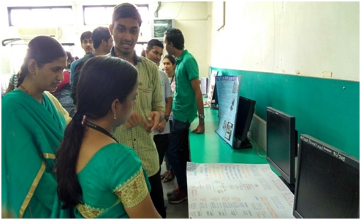
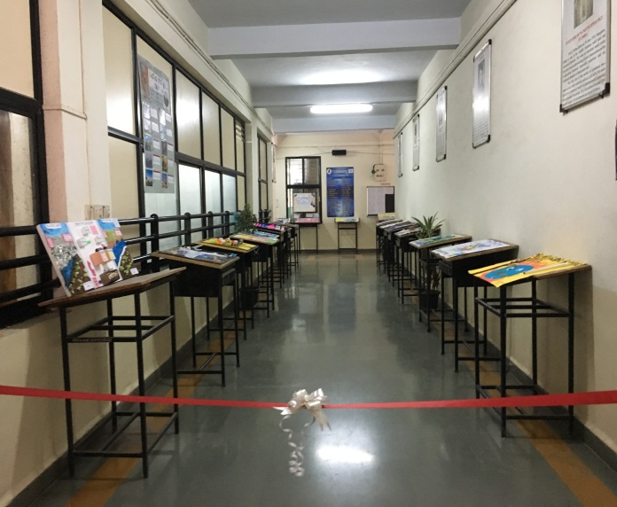
Poster Presentation

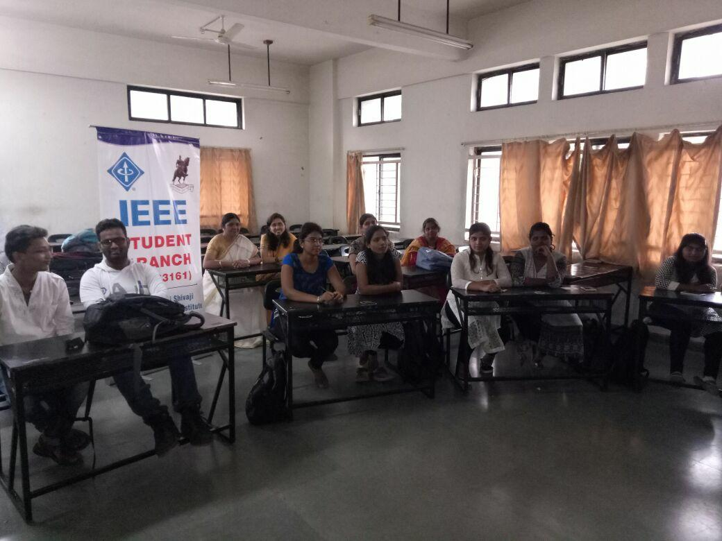

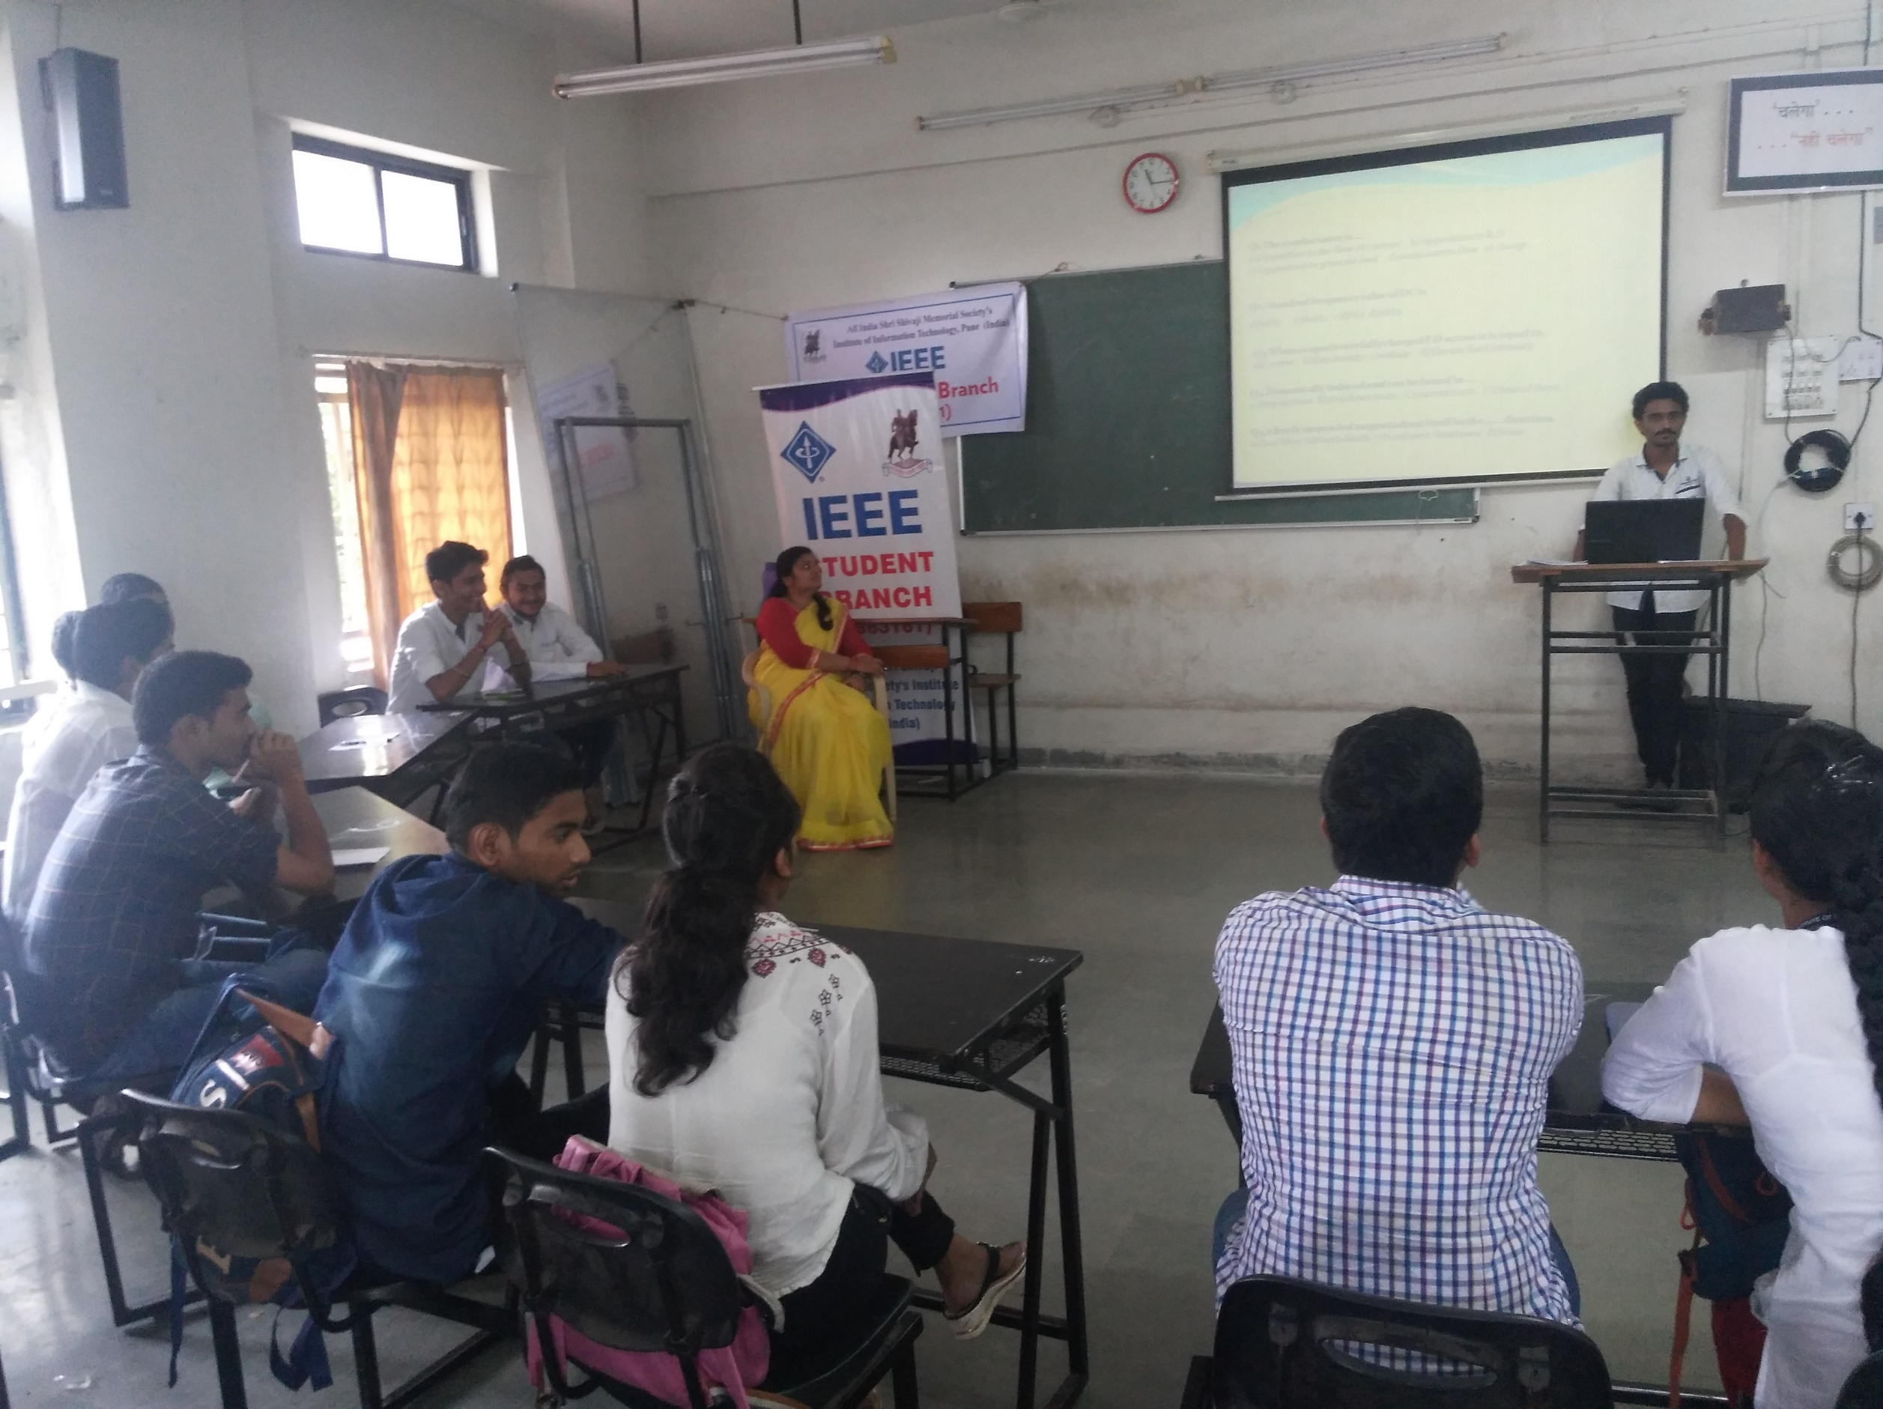
Quiz Competition

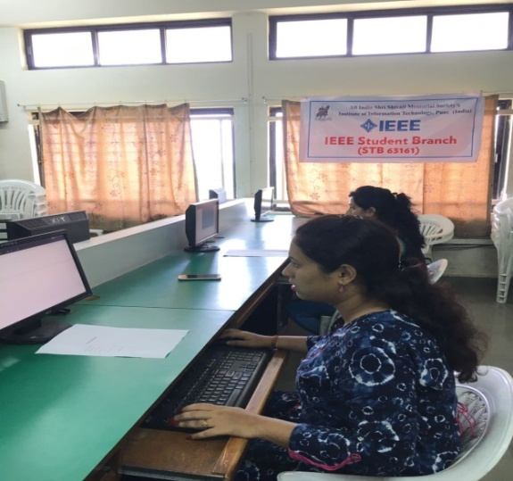
Circuit Design C Code Generation
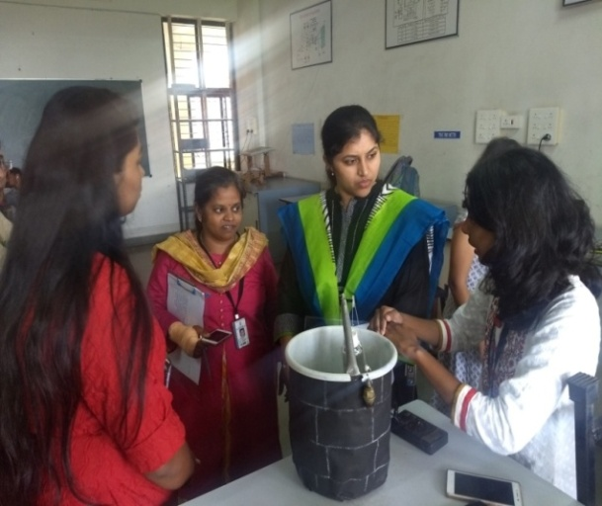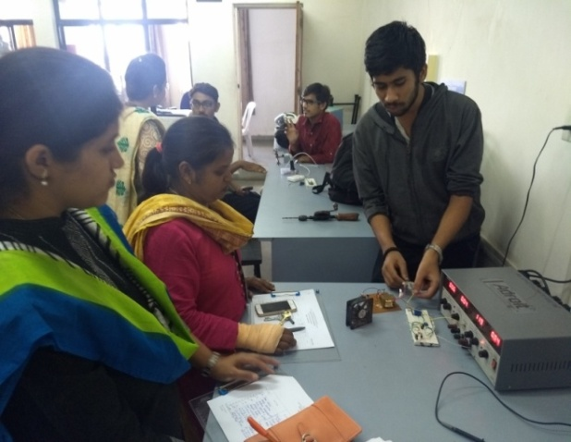
Model Competition

